Unit 6 Work quietly!
Part B 第1课时（Let’s try-Let’s talk）
一、听录音，选择你所听到的选项。
（ ）1. A. show B. she C. shop
（ ）2. A. thing B. anything C. any
（ ）3. A. else B. elephant C. eleven
（ ）4. A. quickly B. quick C. quietly
二、听录音，排序。
（ ）1. Talk quietly!
（ ）2. No eating!
（ ）3. Keep your desk clean!
（ ）4. Work quietly!
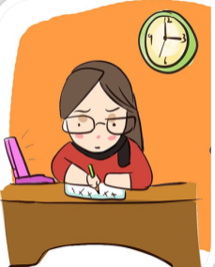
三、将句子的序号写在对应图片下面的括号里。

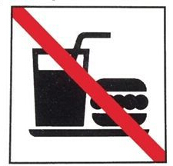


1. ( ) 2. ( ) 3. ( ) 4. ( )
A. Keep your desk clean. B. Work quietly!
C. No eating! D. Talk quietly!
四、连词成句。
1. they, here, are (.)
_____ _____
2. your, desk, keep, clean (.)
_____ _____
3. I, the, English books, you, can, show (.)
_____ _____
五、阅读对话，判断正（T）误（F）。
Sarah: Hello, I’m Sarah. What’s your name?
Mike: I’m Mike.
Sarah: Can I see your English book?
Mike: Talk quietly! We are in the classroom now. Oh, where is my English book?
Sarah: Is that your English book?
Mike: Yes, it is. Here you are.
Sarah: Thanks. You should keep your desk clean.
Mike: OK, I will.
( ) 1. Sarah is reading her English book.
( ) 2. Mike and Sarah are talking.
( ) 3. Mike’s desk is very clean now.
( ) 4. Sarah and Mike are in the classroom now.
( ) 5. Sarah and Mike are good friends.

答案：
一、1. A 2. B 3. A 4. C
二、2 3 4 1
三、1. D 2. C 3. A 4. B
四、1. Here they are. 2. Keep your desk clean.
3. I can show you the English books.
五、1. F 2. T 3. F 4. T 5. F

听力材料：
一、听录音，选择你所听到的选项。
1. show 2. anything 3. else 4. quietly
二、听录音，排序。
1. Work quietly!
2. Talk quietly!
3. No eating!
4. Keep your desk clean!

