Unit 6 Work quietly!
Part A 第2课时（Let’s learn-Look and say）
一、听录音，判断下面句子是（√）否（×）正确。
( ) 1. What’s Chen Jie doing?
( ) 2. She is listening to music.
( ) 3. What are the students doing?
( ) 4. They are listening to music.
二、听录音，给下面图片排列顺序。
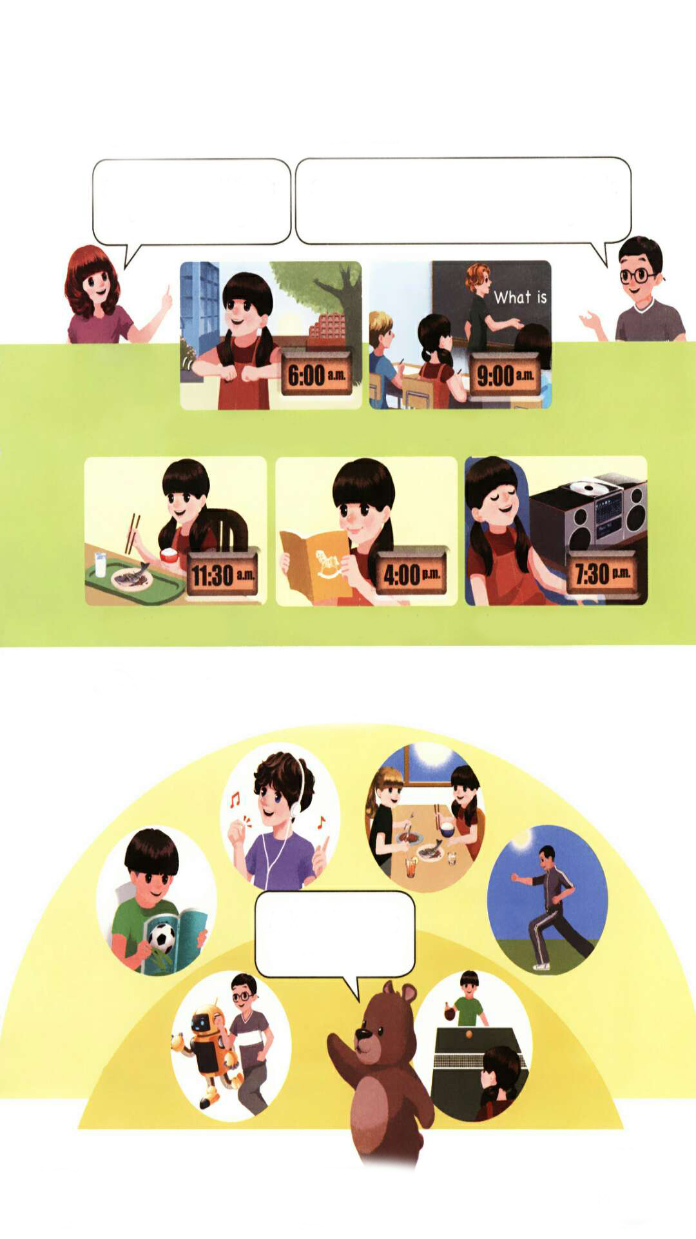
( ) ( ) ( ) ( )


三、根据图片，用现在分词写出短语。


1.____________ 2. __________ __
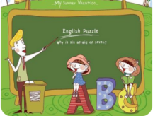

3.____________ 4. __________ __
四、单项选择。
( ) 1. What are you_____?
A. do B. doing
( ) 2. —What are you doing? —I’m_____ lunch.
A. eating B. eat
( ) 3. —Are they listening to music? —_______
A. Yes, they aren’t. B. No, they aren’t.

五、根据图片，完成对话。

1. 2.
A: are the lions ? A: she ?

B: They playing. B: .
3. 4.

A: ? A: ?
B: She’s . B: .

答案：
一、1. T 2. F 3. F 4. T
二、3 1 2 4
三、1. reading a book 2. listening to music 3. doing morning exercises
4. having …class
四、1. B 2. A 3. B
五、1. What; doing; are 2. What’s; doing; She is writing
3. What is she doing; cooking
4. What is the boy doing; He’s eating lunch

听力材料：
一、听录音，判断下面句子是（√）否（×）正确。
1. What’s Chen Jie doing?
2. She is eating.
3. What are the rabbits doing?
4. They are listening to music.
二、听录音，给下面图片排列顺序。
1. eating lunch
2. reading a book
3. doing morning exercises
4. listening to music

