Unit 6 Work quietly!
满分:100分 时间:60分钟 得分:
听力部分
一、听录音,给下列图片排序。(10分)
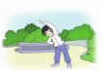
( ) ( ) ( ) ( ) ( )
二、听录音,选择与所听内容相符的句子。(10分)
( )1.A.Mike is answering the phone. B.Mary is reading a book.
C.Mike is reading a book.
( )2.A.My grandpa is cooking dinner. B.My grandpa is cooking noodles.
C.My grandpa is cooking the fish.
( )3.A.Li Ming is drawing pictures. B.Li Ming is watching TV.
C.Li Ming is doing the dishes.
( )4.A.Mary is watching TV. B.Mary is talking on the phone.
C.Mary is doing her homework.
( )5.A.He is doing the dishes. B.She is doing the dishes.
C.She is cooking the meal.
三、听录音,打“􀳫”。(10分)
 | Peter | Peter’s sister | Peter’s father | Peter’s mother
drawing a picture
cooking dinner
talking on the phone
reading a book

笔试部分
四、看图选择正确的词组。(10分)
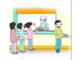
A.doing homework B.clean the room C.take turns
D.listening to music E. keep quiet
五、选择正确的答案。(10分)
( ) 1.I am .
A.doing my homework
B.read the books
C.listen to music
( )2.— When do you watch TV?
— I usually watch TV seven o’clock.
A.in B.on C.at
( )3.My grandma likes the room.
A.cleaned B.cleaning C.cleans
( )4.— Work quietly, please. —
A.Yes, I can. B.OK. C.No.
( )5.— What are you doing? —
A.I read a book.
B.I’m doing morning exercises.
C.I’m a student.
六、根据所给提示,完成下列句子。(10分)
1.Keep (you) desk clean.
2.My father is (cook)dinner.
3. (哪一个)season do you like best?
4.— Can I use your ruler? — Of course. (take) turns.
5.Look, they are making a (雪人).
七、给下列句子选出对应的图片。(15分)
( )1.— What’s Zhang Peng doing?
— He is reading a book.
( )2.— What are they doing?
— Oh, they are planting a tree.
( )3.I usually visit my grandparents on the weekend. But this weekend I am having maths class at school.
( )4.My mother is cooking meals and I am drawing pictures.
( )5.They are talking on the phone.
A. B. 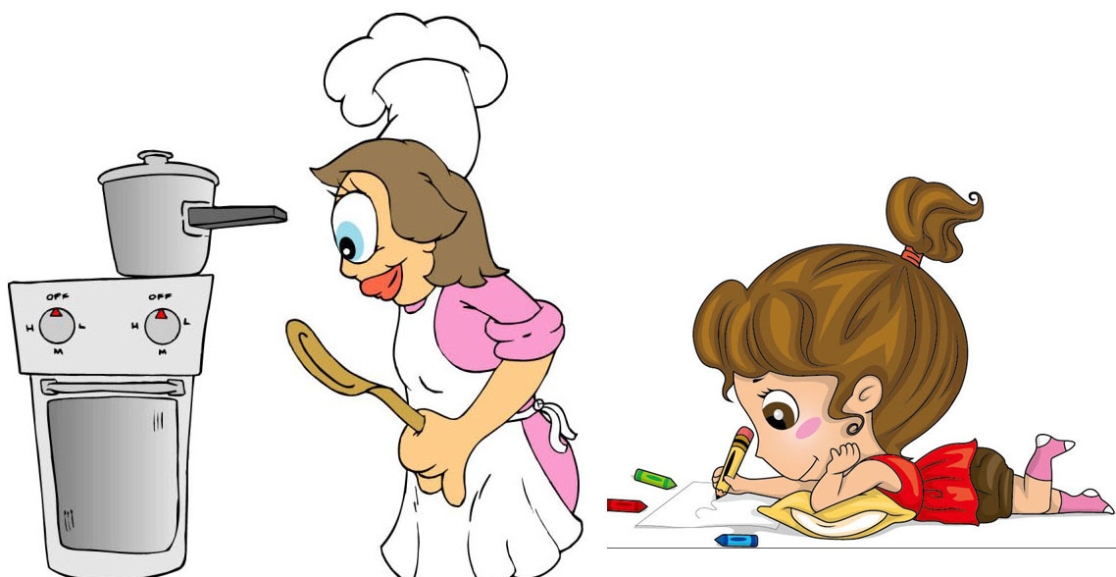 C. D. E.
八、阅读短文,回答问题。(15分)
Today is Sunday.It’s a sunny day. Many students are in the Shiji Park. They are very happy. Look, Jack and Kate are drawing pictures near the flowers. Amy is reading the books under a big tree. Peter, John and Tom are swimming. Chen Jie and Sarah are flying kites. What a good time they are having!
1.What day is it today?

2.What are Jack and Kate doing?

3.Is Amy reading the books near the flowers?

4.How many students are there in the park?

5.Who’s flying kites?

九、写作。(10分)
Mike要打电话给Lora,询问她家人在干什么,并且Mike 想邀请她周日上午八点去动物园。
1.根据内容编写段对话。
2.注意电话用语的使用。

