Unit 5 Whose dog is it?
Part B 第2课时（Let’s learn-Let’s play）
一、听录音，选择你所听到的选项。
（ ）1. A. climb B. class C. climbing
（ ）2. A. play B. please C. playing
（ ）3. A. drink B. drinking C. dress
（ ）4. A. sleeping B. school C. see
二、听录音，排序。
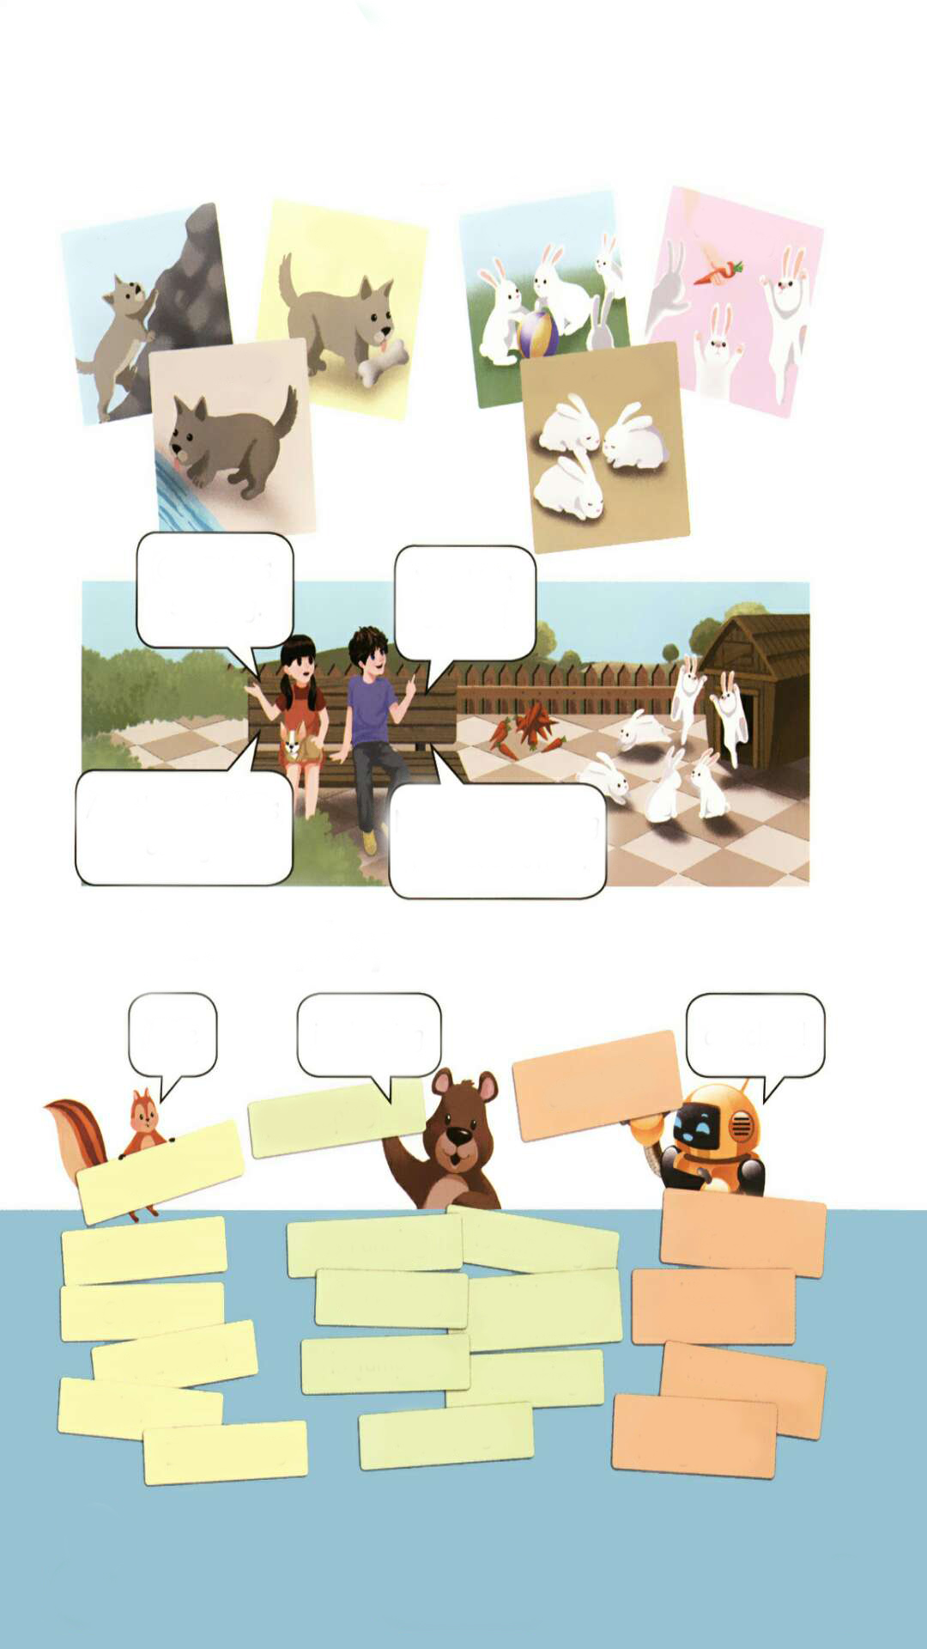
( ) ( ) ( ) ( )
三、写出下列单词的-ing的形式。
1. climb_______ 2. eat___________ 3. play__________
4. jump__________ 5. run___________ 6. drink___________
7. sleep__________ 8. read__________
四、看下表，仿写句子
Mike is sleeping at school.
1.____________ _____
2._____________ _____
3.________ ___________
4._____ _______________
Mike  Chen Jie  Oliver  Wu Binbin  John | is sleeping  is listening to music  is running  is reading  is jumping | at school  with her friend  in the park  under the tree  in the living room
五、阅读短文，选择正确答案。
Today is Sunday. Mike’s family is at home. His father Mr Black is reading a book in the living room. His mother is cooking in the kitchen. His brother Tom and his friend John are playing chess in the bedroom. His grandpa and grandma are watching TV in the living room. Where is Mike?
（ ）1. It’s _______ today.
A. Sunday B. sunny C. Saturday
（ ）2. Mr Black is _________.
A. cooking B. watching TV C. reading a book
（ ）3. _________ is cooking in the kitchen.
A. Mike B. Mike’s father C. Mike’s mother
（ ）4. Tom and John are _______ in the bedroom.
A. sleeping B. playing chess C. watching TV
（ ）5. Mike’s grandpa is in the _______.
A. kitchen B. study C. living room

答案：
一、1. C 2. C 3. B 4. A
二、3 2 1 4
三、1. climbing 2. eating 3. playing 4. jumping 5. running 6. drinking
7. sleeping 8. reading
四、1. Chen Jie is listening to music with her friend. 2. Oliver is running in the park.
3. Wu Binbin is reading under the tree. 4. John is jumping in the living room.
五、1. A 2. C 3. C 4. B 5. C

听力材料：
一、听录音，选择你所听到的选项。
1. climbing 2. playing 3. drinking 4. sleeping
二、听录音，排序。
1. The rabbits are playing.
2. The dog is eating.
3. The dog is climbing.
4. The rabbits are jumping.

