Unit 5 Whose dog is it?
Part A 第2课时（Let’s learn-Look, say and complete）
一、听录音，判断下面句子是（√）否（×）正确。
( ) 1. That’s my dog.
( ) 2. That’s John’s cat.
( ) 3. It’s her book.
( ) 4. Whose book is that?
二、听录音，给下面图片排列顺序。
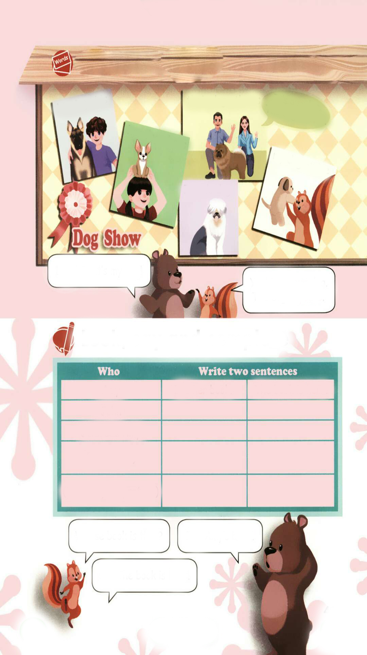
( ) ( ) ( ) ( )
三、选出不同类的一项。
( ) 1. A. theirs B. us C. ours
( ) 2. A. mine B. hers C. your
( ) 3. A. your B. ours C. their
四、选择正确的词，填在横线上。
1. The blue pencil is __________ (my, mine ).
2. This is not my dog. It’s _________ ( she, hers).
3. —Whose pictures are these?
—They are _________( we , ours).
4. Is this __________ (Amy, Amy’s ) desk?
5. The white cat is _______ (he, his ).
五、改写同义句。
1. It’s your dog.__________________
2. It’s my cat.____________________
3. It’s his cap._____________________-
4. It's her storybook.________________
5. These are our books._______________
6. Those are their pens._______________
六、照例子，仿写句子。
例：water bottle, Tom
—Whose water bottle is it?
—The water bottle is Tom’s. It’s his.
1. bike, Amy

2. books, Tim and Sam

答案:
一、1. √ 2. × 3. √ 4. ×
二、3 1 2 4
三、1. B 2. C 3. B
四、1. mine 2. hers 3. ours 4. Amy’s 5. his
五、1. The dog is yours. 2. The cat is mine. 3. The cap is his.
4. The storybook is hers. 5. The books are ours. 6. Those pens are theirs.
六、1. —Whose bike is it?
—The bike is Amy’s. It’s hers.
2. —Whose books are they?
—The books are Tim and Sam’s. They are theirs.

听力材料：
一、听录音，判断下面句子是（√）否（×）正确。
1. That’s my dog.
2. That’s John’s dog.
3. It’s her book.
4. Whose book is this?
二、听录音，给下面图片排列顺序。
1. her dog
2. their dog
3. his dog
4. Zip’s dog

