Unit 4 When is the art show？
Part B 第2课时（Let’s learn-Look and write）
一、听录音，选择你所听到的选项。
（ ）1. A. two B. tall C. twelfth
（ ）2. A. team B. tea C. twentieth
（ ）3. A. teach B. twenty C. third
（ ）4. A. thirtieth B. take C. things
二、听录音，排序。
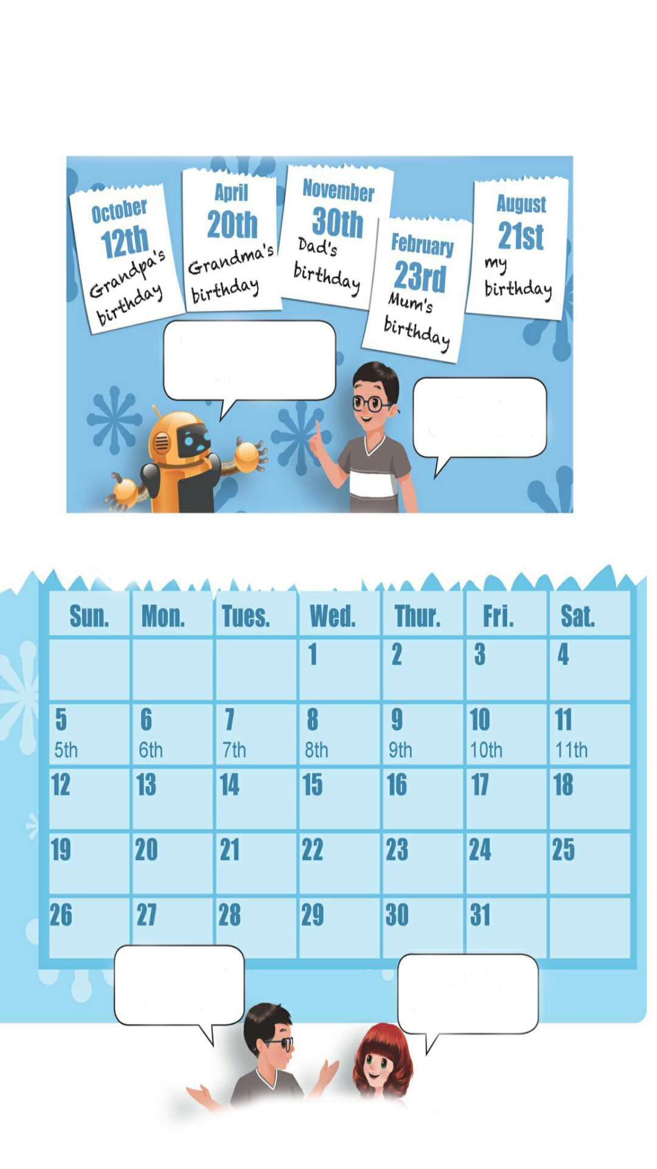

( ) ( ) ( ) ( )
三、读一读，按照例子写一写。
例：1月10日—January 10th
1. 2月23日________________ 2. 3月5日________________
3. 6月24日________________ 4. 10月29日________________
5. 8月20日________________ 6. 11月27日________________
四、用所给词的适当形式填空。
1. Mother’s Day is on the_____（two）Sunday in May.
2. There are ______（third）boys in the room.
3. I see _____（five）kites in the sky.
4. I go to school at _______（seven）in the morning.
5. Dad’s birthday is on January_____（one）.
6. It is ______ （twelve）o’clock.
7. December______（twenty-five）is Christmas Day.
五、情景交际。
1.如果你想询问别人的生日在哪天，应该说：_________
A. What is your birthday? B. When is your birthday?
2.如果你想告诉别人你的生日是6月2日，应该说：_________
A. My birthday is on June 2nd. B. My birthday is on June two.
3.如果你想知道爷爷的生日是哪天，应该说：_________
A. When is Grandma’s birthday? B. When is Grandpa’s birthday?
六、根据所给提示，写一篇关于你家人生日的短文。
Hello. There are ______ people in my family.______________________
_____________________. My father’s birthday is on _______.My mother’s birthday is on ___________.My birthday is on______________. I love my family very much.

答案：
一、1. C 2. C 3.B 4.A
二、3 2 1 4
三、1. February 23rd 2. March 5th 3. June 24th
4. October 29th 5. August 20th 6. November 27th
四、1. second 2. three 3. five 4. seven 5. 1st 6. twelve 7. 25th
五、1. B 2. A 3. B
六、three;
They are my father, my mother and me;
March 5th;
March 24th;
Mar. 5th（答案不唯一）

听力材料：
一、听录音，选择你所听到的选项。
1. twelfth 2. twentieth 3. twenty 4. thirtieth
- 听录音，排序。
1. Dad’s birthday is on November 30th.
2. Grandma’s birthday is on April 20th.
3. Grandpa’s birthday is on October 12th.
4. Mum’s birthday is on February 23rd.

