Unit 4 When is the art show？
Part A 第2课时（Let’s learn-Ask and answer）
一、听录音，判断下面句子是（√）否（×）正确。
( ) 1. School trip is on Mar. 5th.
( ) 2. Singing contest is on Jul. 1st.
( ) 3. Miss Chen’s birthday is on Sept. 2nd.
( ) 4. English test in on Nov. 2nd.
二、听录音，给下面图片排列顺序。
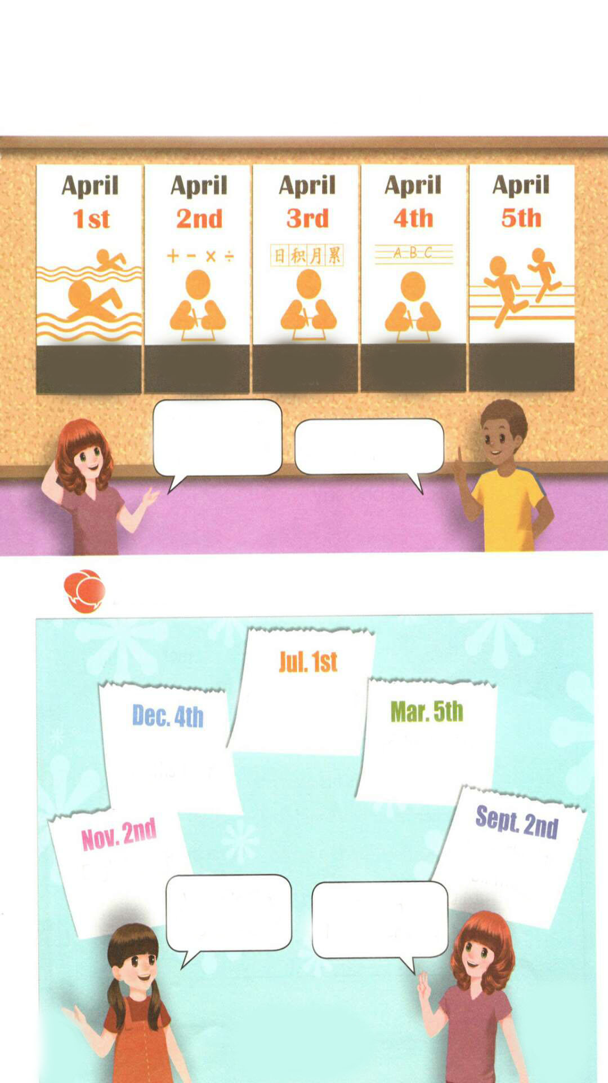
( ) ( ) ( ) ( )
三、给下列单词排序，并按顺序写出它们的缩写形式。
fifth second first fourth third
排序：________________ ____
缩写：______________________________
四、读一读，按照例子写一写。
例：9.1—Sept. 1st
1. 3.5— 2. 4.5— 3. 6.3—
4. 1.1— 5. 7.4— 6. 8.2—
五、根据句子意思选择恰当的单词填空。
1. Today is my brother's _________(five /fifth) birthday.
2. There are__________(four /fourth) seasons in a year.
3. Mother's Day is on the_________( two/second) Sunday in May.
4. My little brother is__________(three/third) years old.
六、仿照例句，根据所给内容编写对话。
Nov. 2nd
English test
例： When is the English test?
It’s on November 2nd.
Dec. 4th
maths test
Jun. 1st
singing contest
1. 2.
A: A:
B: B:
Mar. 5th
school trip
Sept. 3rd
my mother’s
birthday
3. 4.

A: A:
B: B:

答案：
一、1. × 2. √ 3. √ 4. ×
二、3 1 2 4
三、排序：first second third fourth fifth 缩写：1st 2nd 3rd 4th 5th
四、1. Mar.5th 2. Apr. 5th 3. Jun.3rd
4. Jan. 1st 5. Jul. 4th 6. Aug. 2nd
五、1. fifth 2. four 3. second 4. three
六、1. When is the maths test?
It’s on December 4th.
2. When is the singing contest?
It’s on June 1st.
3. When is the school trip?
It’s on March 5th.
4. When is your mother’s birthday?
It’s on September 3rd.

听力材料：
一、听录音，判断下面句子是（√）否（×）正确。
1. School trip is on Mar. 7th.
2. Singing contest is on Jul. 1st.
3. Miss Chen’s birthday is on Sept. 2nd.
4. Chinese test in on Nov. 2nd.
二、听录音，给下面图片排列顺序。
1. maths test
2. Chinese test
3. swimming contest
4. English test

