Unit 4 When is the art show?
满分:100分 时间:60分钟 得分:
听力部分
一、听录音,给下列图片排序。(10分)
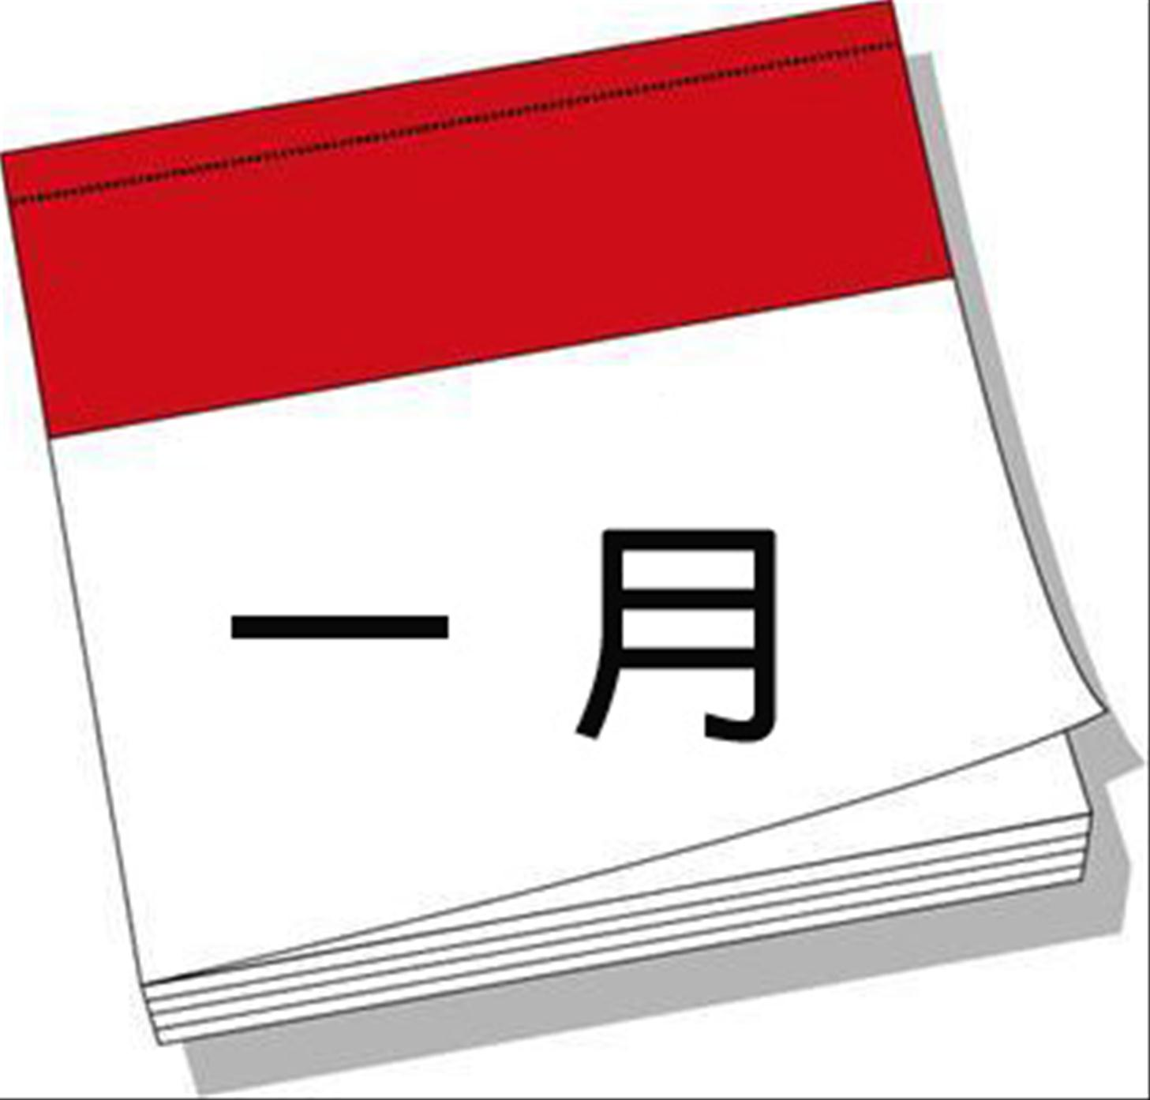( )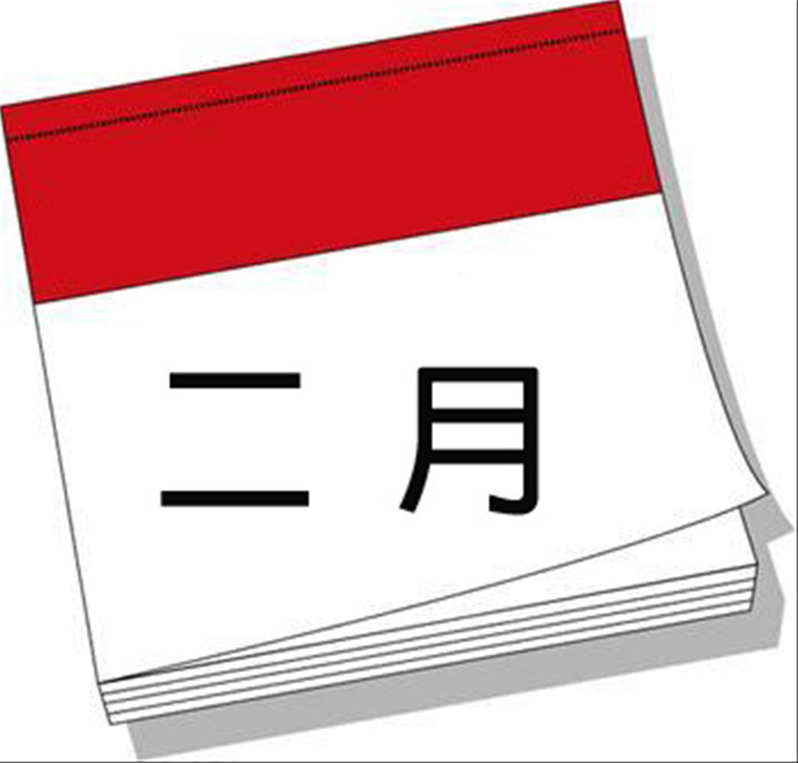( )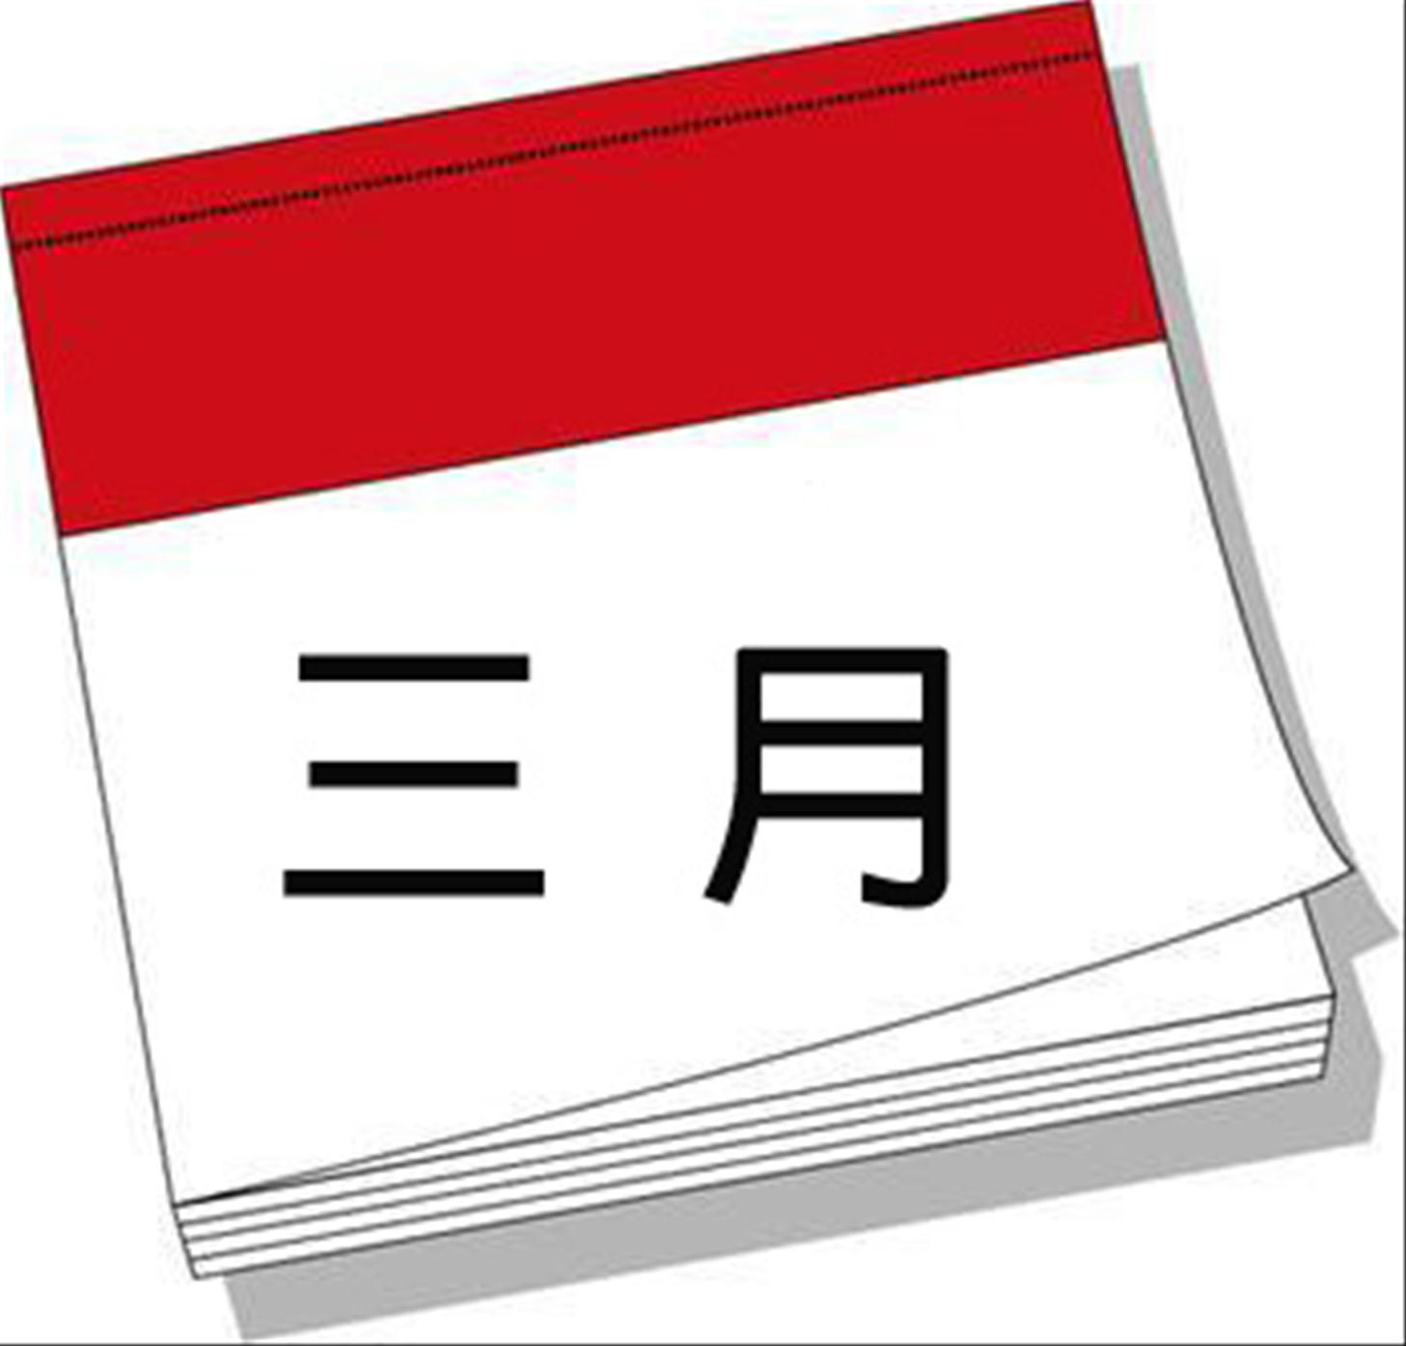( )
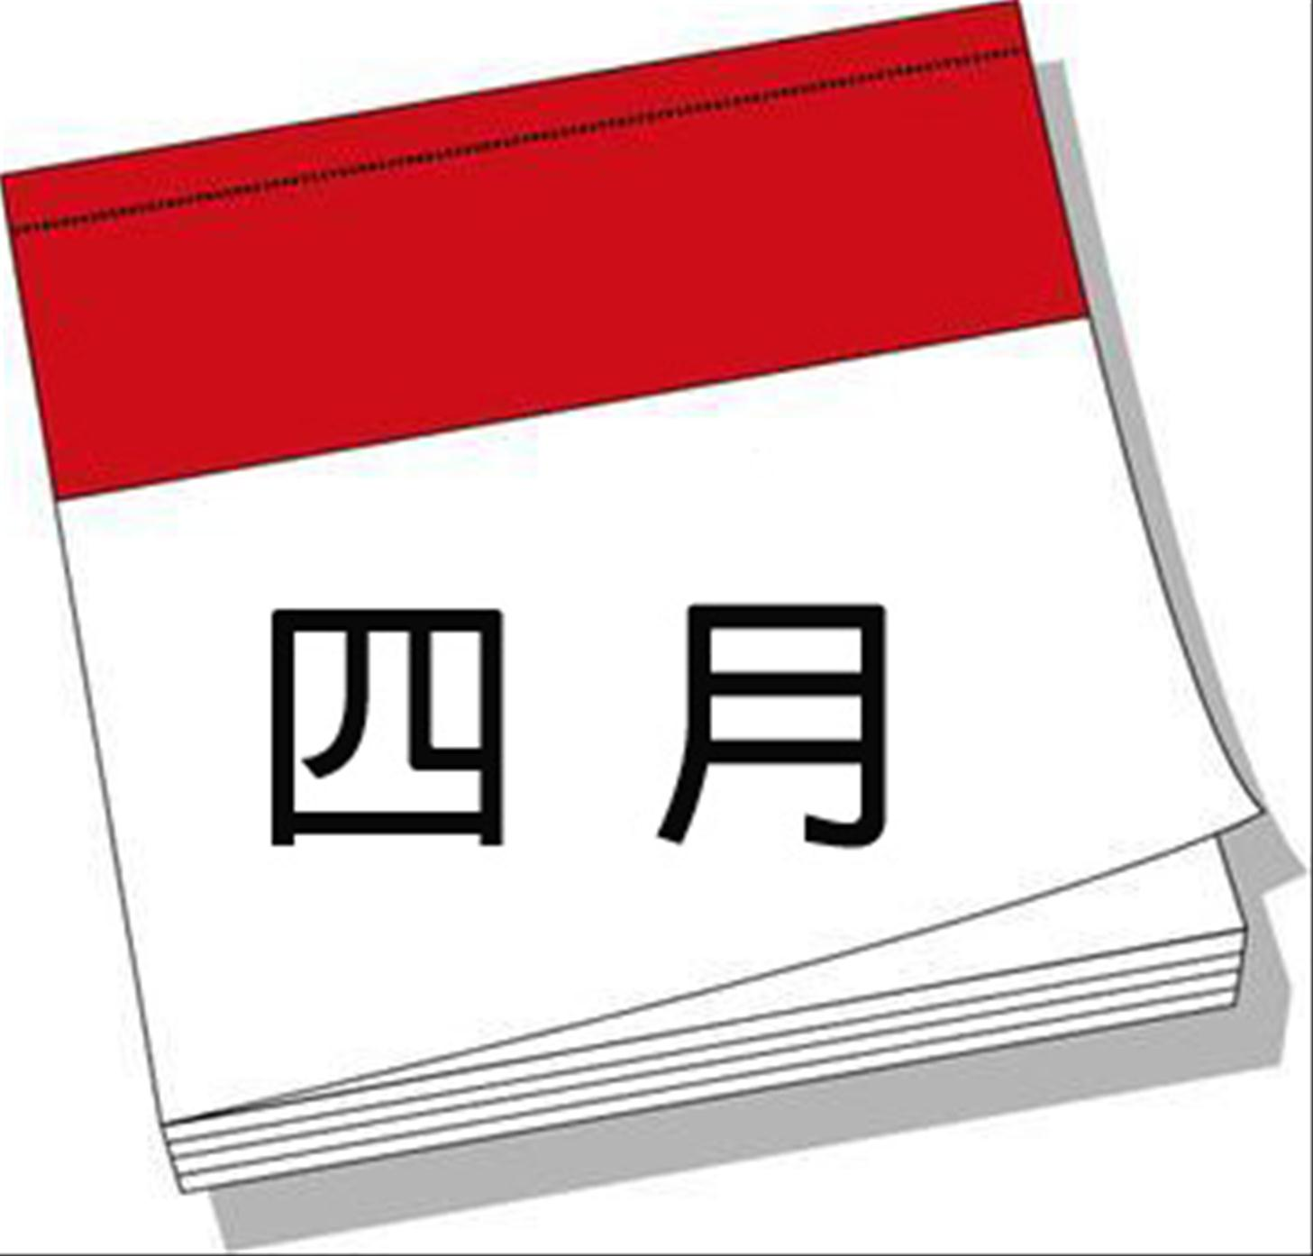( )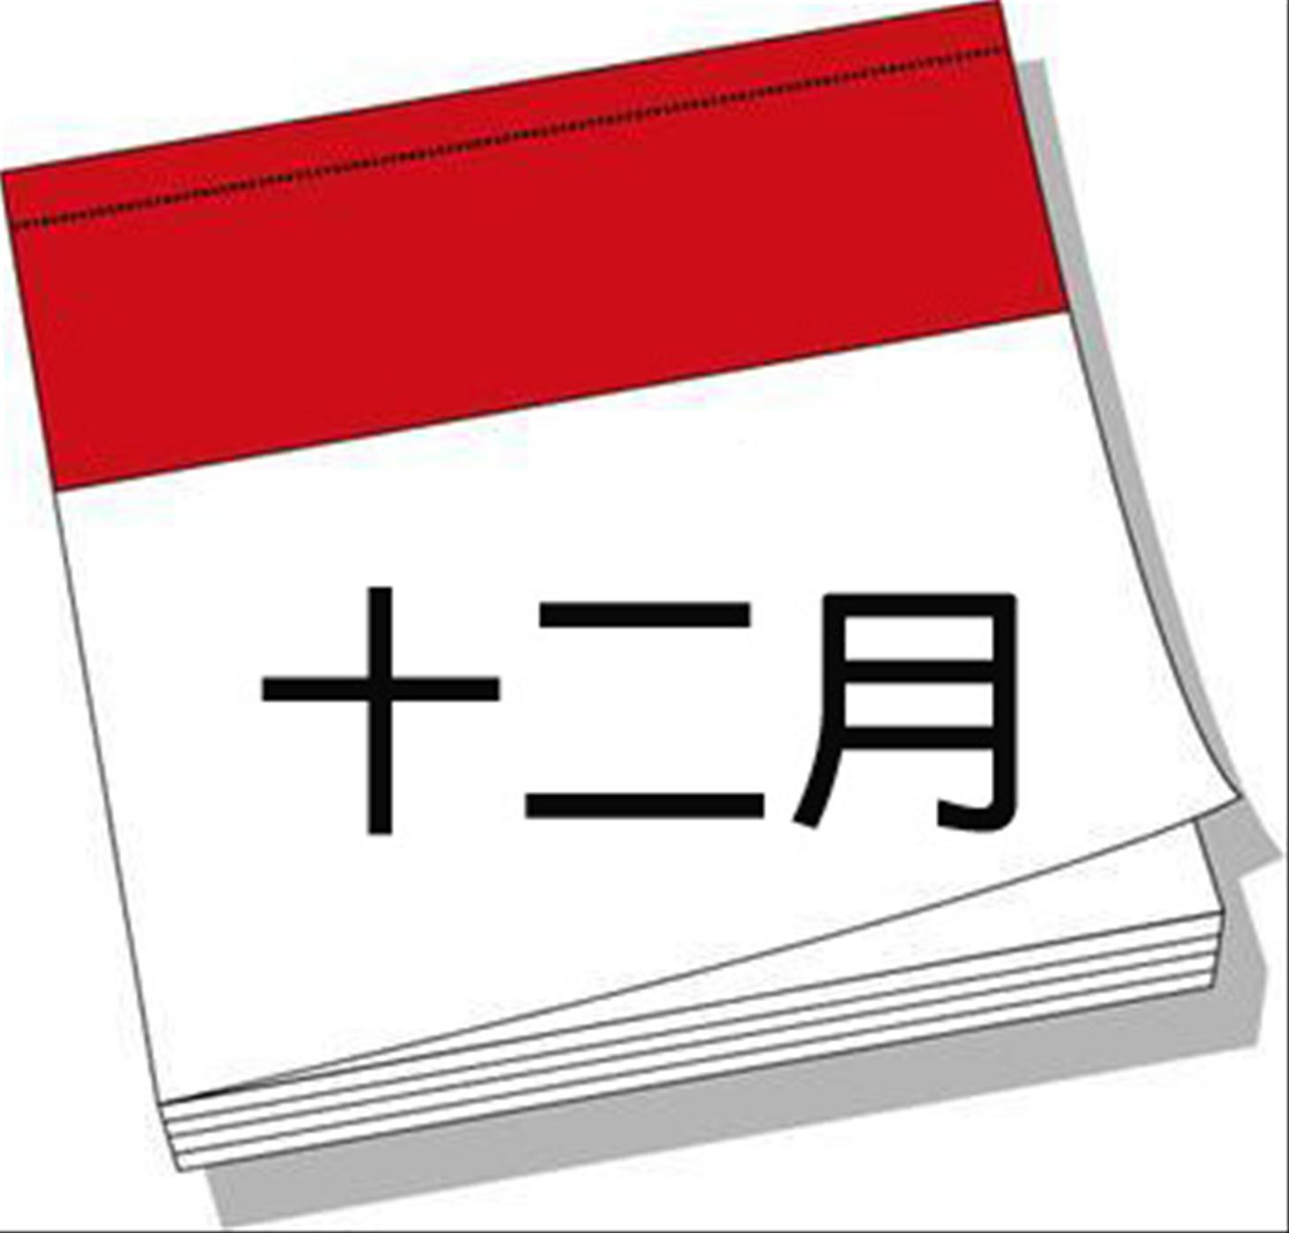（ )
二、听录音,选单词或词组。(10分)
( )1.A.November B.December C.September
( )2.A.January B.February C.October
( )3.A.March 12th B.March 22nd C.March 2nd
( )4.A.Children’s Day B.National Day C.Christmas Day
( )5.A.June 9th B.July 9th C.June 19th
三、听录音,判断正(T)误(F)。(10分)
( )1.Lisa’s birthday is on July 5th.
( )2.Grandma’s birthday is on December 3rd.
( )3.Dan and I like playing sports.
( )4.Uncle’s birthday is on March 12th.
( )5.My cat, Jack’s birthday is on January 6th.
笔试部分
四、写出下列节日的中文及日期。(10分)
1.Tree Planting Day
2.New Year’s Day
3.Children’s Day
4.National Day
5.Christmas Day
五、选择正确的答案。(10分)
( )1.— has a birthday in October?
— Me.
A.Whose B.Who C.Who’s
( )2.—
— It’s on September 10th.
A.What time is it?
B.When is Teachers’ Day?
C.What day is it today?
( )3.My birthday is March.
A.in B.on C.of
( )4. is the second day of a week.
A.Sunday B.Tuesday C.Monday
( )5.I’m a doctor. I get up 10:00 the morning.
A.at; in B.at; at C.in; in
六、给下列句子选择合适的答语。(10分)
( )1.When is your birthday?
( )2.Is your birthday in May?
( )3.Who has a birthday in June?
( )4.What’s the date?
( )5.What are you doing?
A.Yes.
B.It’s in October.
C.It’s Oct.1st.
D.I’m writing a letter.
E.Me.
七、根据所给的图片或答句,回答问题或写出问句。(15分)
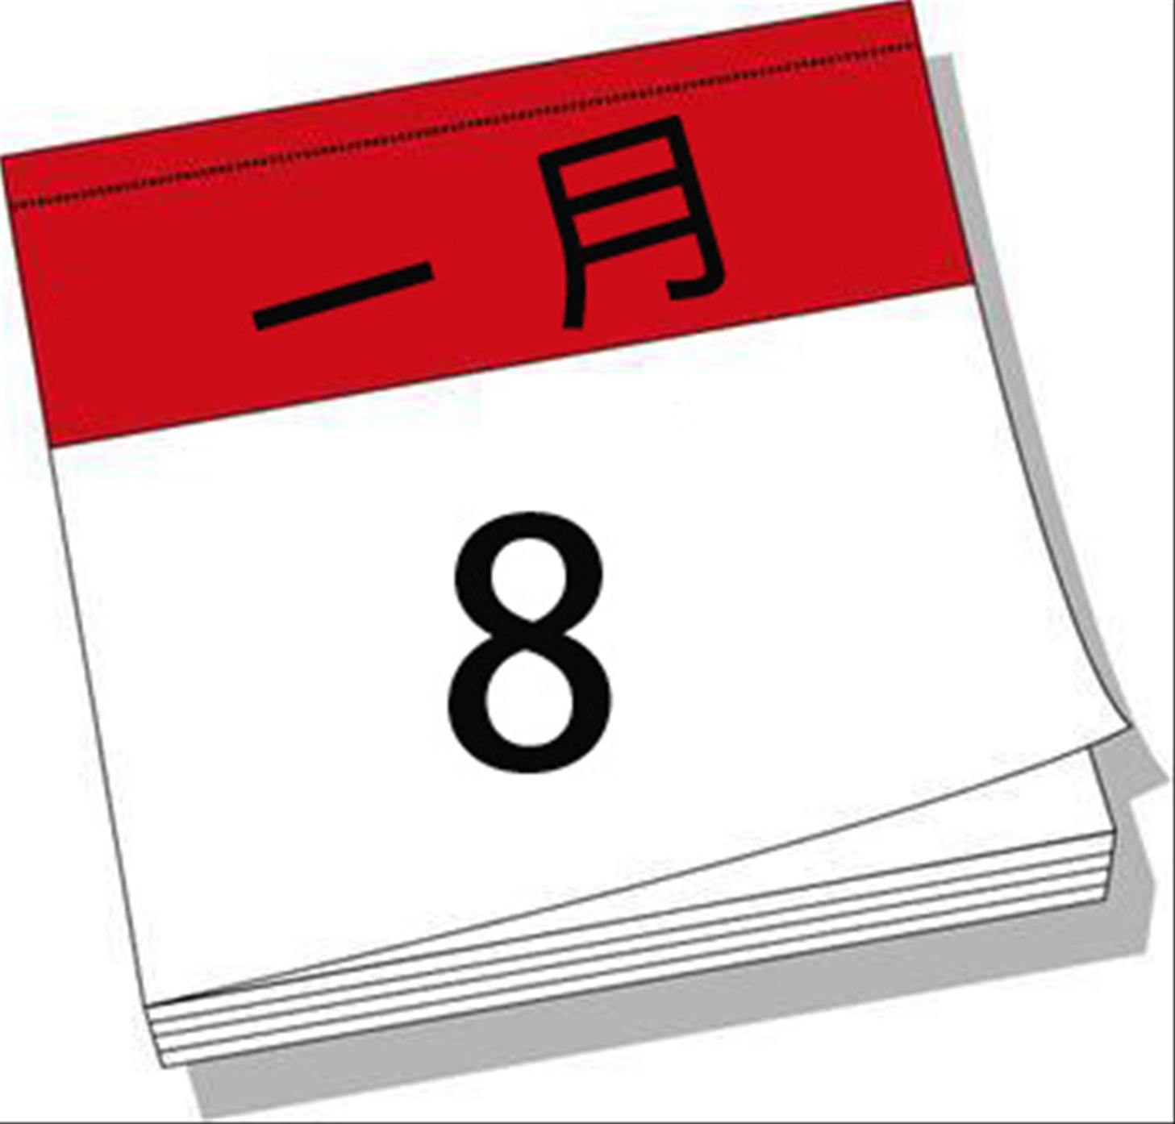

1.When is your birthday?

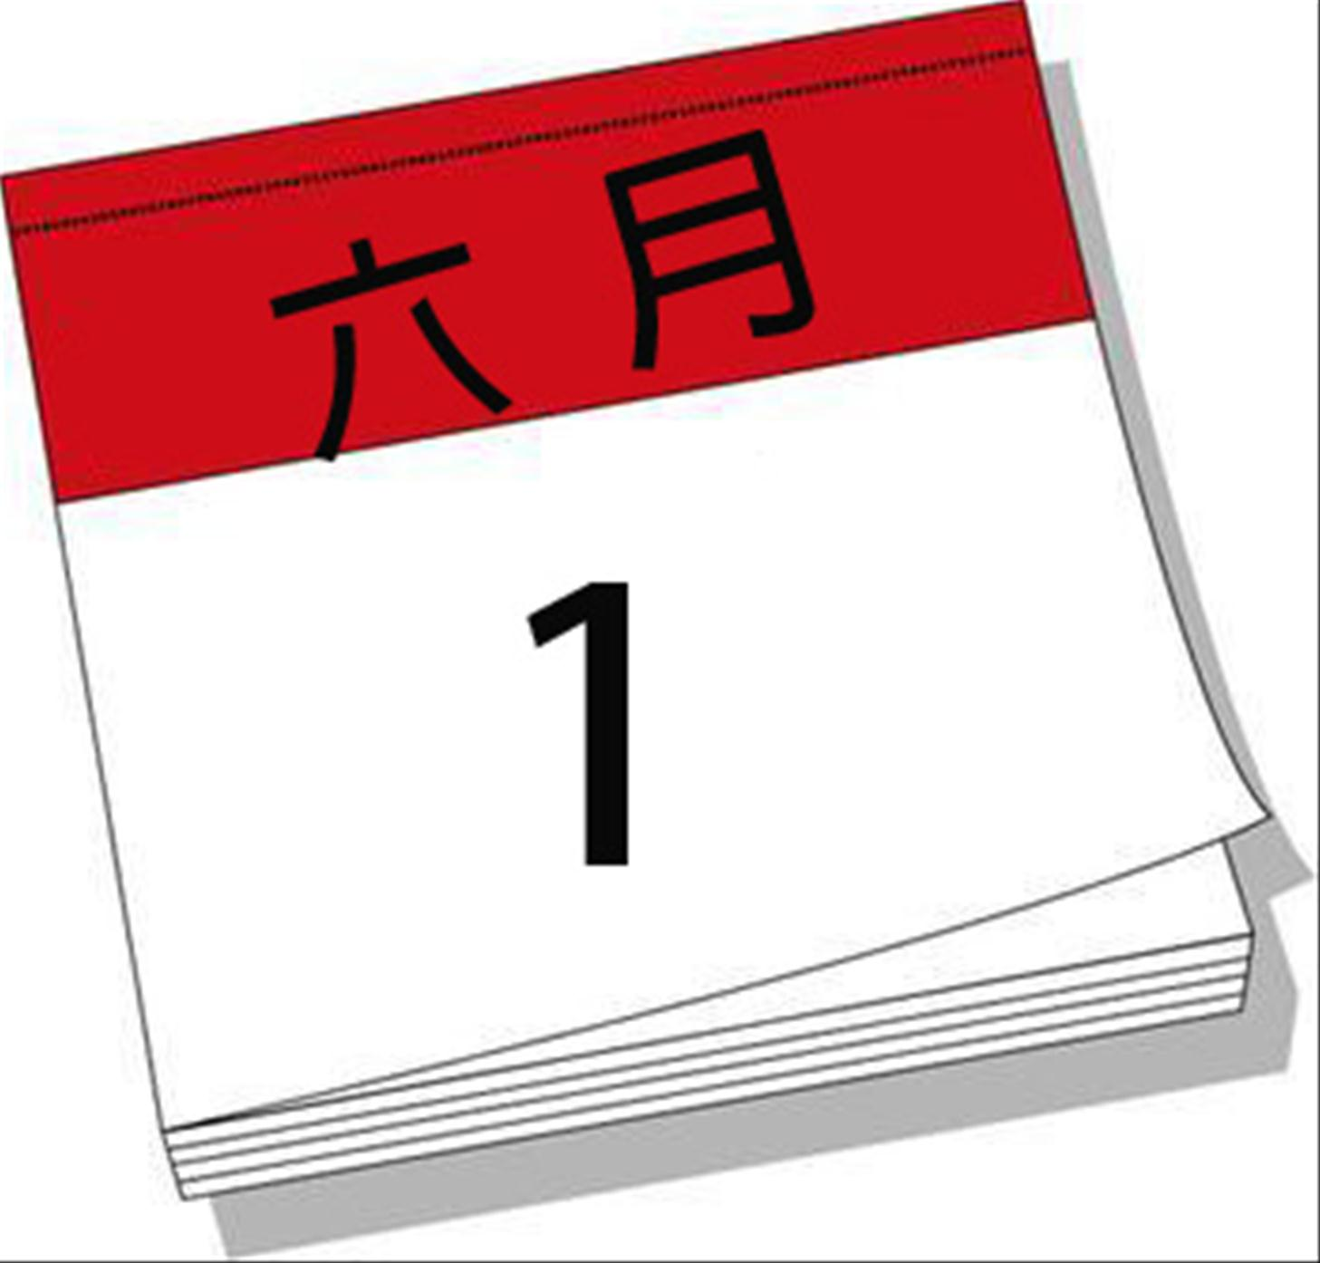
2.Is today Christmas Day?

3.
Yes, Mary’s birthday is in October.
4.
The sports meet is in March.

5.Does she have a cake?

八、阅读短文,判断正(T)误(F)。(15分)
There are some holidays in each season in China. In spring, there is the Spring Festival in January or February, children can get the lucky money in this festival. Then Tree Planting Day comes after Women’s Day. When summer comes, there is a Dragon Boat Festival in June, people often row boats in the river. Children like June best, because Children’s Day is in June. August 1st is Army Day, and Mid-Autumn Day comes. At the end of the last day of a year, we celebrate the first day of a new year. That is the New Year’s Day!
( )1.Children can get the lucky money in January or February.
( )2.Women’s Day comes before Tree Planting Day.
( )3.People often row boats in the river in May.
( )4.Mid-Autumn Day is on August 1st.
( )5.The New Year’s Day is at the end of the last day of a year.
九、小作文。用英语写至少五句话,写一写你的生日是哪天,你家人的生日又是哪天,过生日的时候常常做什么事情,吃什么东西,心情怎么样。(10分)

