Unit 3 My school calendar
Part B 第2课时（Let’s learn-Ask and write）
一、听录音，选择你所听到的选项。
（ ）1. A. July B. jump C. juice
（ ）2. A. autumn B. August C. all
（ ）3. A. second B. September C. snow
（ ）4. A. number B. November C. October
二、听录音，排序。
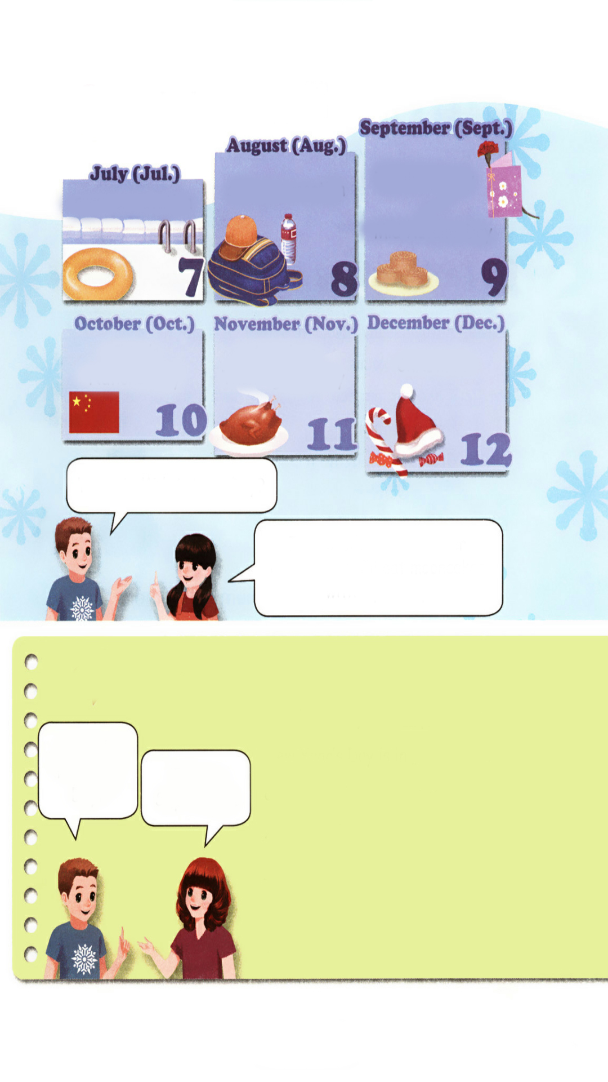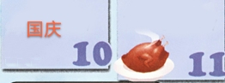
( ) ( ) ( ) ( )
三、找出不同类的单词，将序号填在括号里。
( ) 1. A. holiday B. who C. which
( ) 2. A. birthday B. Children’s Day C. National Day

( ) 3. A. April B. autumn C. August
四、看图填空。

1. Teachers’ Day is in ________.

2. China’s National Day is in________.

3. American Thanksgiving Day is in________.

4. Christmas is in_________.

5. Mid-Autumn Festival is in__________.
五、阅读理解，选择正确答案。
Mid­Autumn Festival is on August 15th in the lunar calendar (阴历). On that day, families get together to celebrate it. At night, we sit in the open air (露天), enjoy the bright round moon and eat mooncakes and fruit. We all have a good time on that day. It's said (据说) that there is a beautiful woman called Chang'e, who lives on the moon with her rabbit.
( ) 1. Mid­Autumn Festival is on ________ in the lunar calendar.
A. January 15th B. August 15th C. May 15th
( ) 2. What do we do on that day?
A. Enjoy the moon. B. Eat mooncakes and fruit. C. A and B.
( ) 3. It's said that Chang'e lives on the moon with her _______.
A. dog B. rabbit C. cat
( ) 4. People are ________ on that day.
A. happy B. sad C. angry

答案：
一、1. A 2. B 3.B 4.C
二、3 2 1 4
三、1. A 2. A 3. B
四、1. September 2. October 3. November 4. December 5. September or October
五、1. B 2. C 3. B 4. A

听力材料：
一、听录音，选择你所听到的选项。
1. July 2. August 3. September 4. October
二、听录音，排序。
1. China’s National Day is in October.
2. Teachers’ Day is in September.
3. Summer vacation is in August.
4. American Thanksgiving Day is in November.

