Unit 3 My school calendar
Part A 第2课时（Let’s learn-Read and say）
一、听录音，判断下面句子是（√）否（×）正确。
( ) 1. Tree Planting Day is in February.
( ) 2. Mother’s Day is in May.
( ) 3. The sports meet is in April.
( ) 4. Children’s Day is in January.
二、听录音，给下面图片排列顺序。
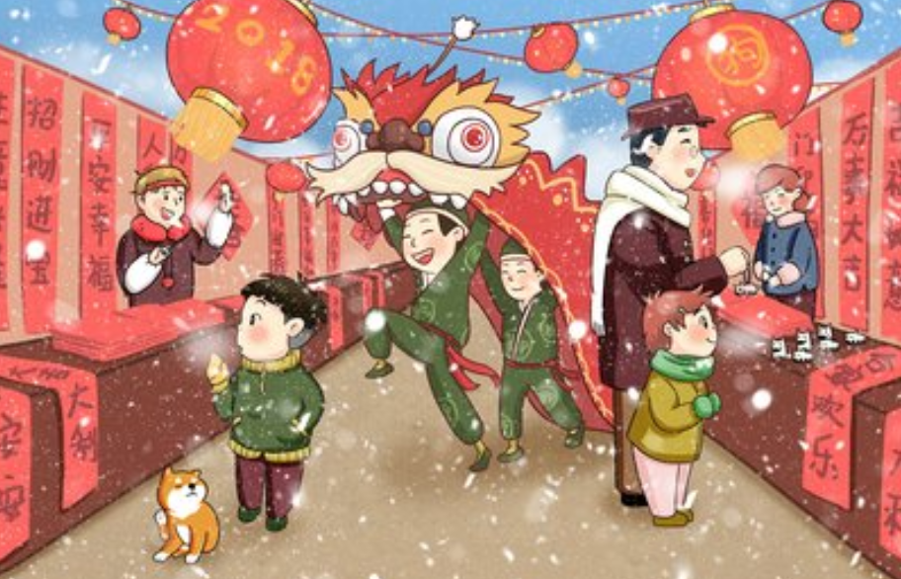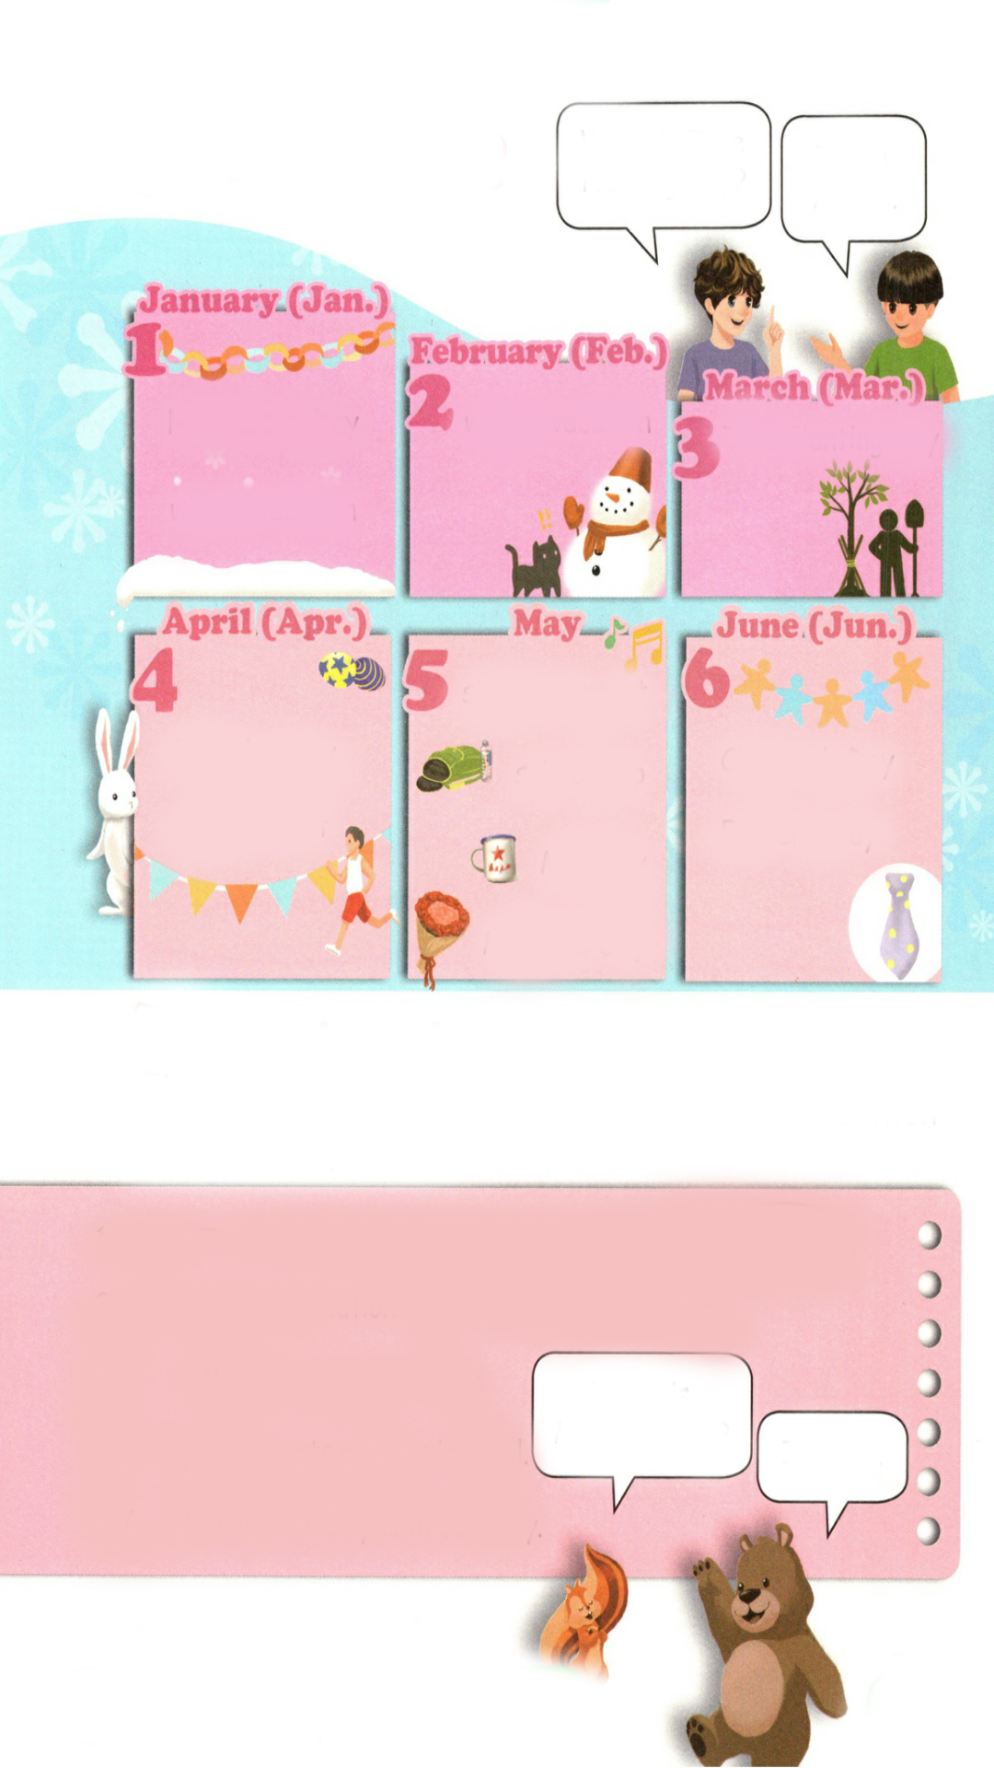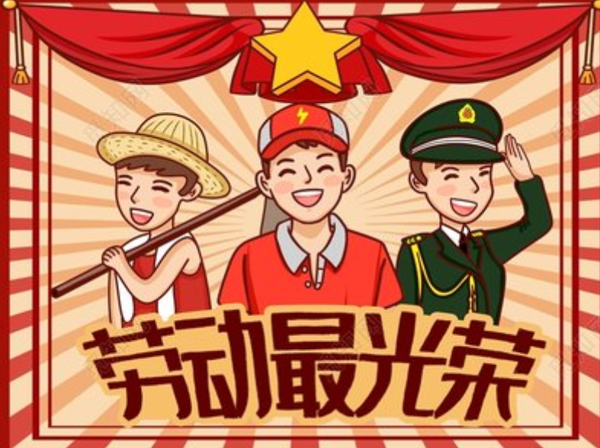
( ) ( ) ( ) ( )
三、将下列月份按时间的顺序排序。
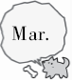
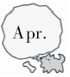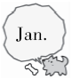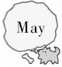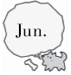
( ) ( ) ( ) ( ) ( ) ( )
四、根据句子意思填写正确的月份，并将相应的图片序号填写在括号里。
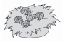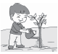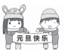
A B C D E
( ) 1. New Year's Day is in ________.
( ) 2. The Easter party is in ________.
( ) 3. Tree Planting Day is in ________.
( ) 4. Children's Day is in ________.
( ) 5. Mother's Day is in ________.
五、根据实际情况判断下列句子的正（T）误（F）。
( ) 1. Father's Day is in May.
( ) 2. New Year's Day is in February.
( ) 3. Winter vacation is usually in January and February in China.
( ) 4. We always have an Easter party in June.
( ) 5. Father's Day and Mother's Day are in the same month.
六、仿照例句，用所给内容完成对话。
例：When is Mother’s Day? It’s in May.
1. Father’s Day
A: B:
2. New Year’s Day
A: B:
3. Children’s Day
A: B:

答案：
一、1. × 2. √ 3. √ 4. ×
二、3 1 2 4
三、4 1 5 6 2 3
四、1. C January 2. A April 3. B March 4. E June 5. D May
五、1. F 2. F 3. T 4. F 5. F
六、1. When is Father’s Day? It’s in June.
2. When is New Year’s Day? It’s in January.
3. When is Children’s Day? It’s in June.

听力材料：
一、听录音，判断下面句子是（√）否（×）正确。
1. Tree Planting Day is in March.
2. Mother’s Day is in May.
3. The sports meet is in April.
4. Children’s Day is in June.
二、听录音，给下面图片排列顺序。
1. Winter vacation is in February.
2. Tree Planting Day is in March.
3. New Year’s Day is in January.
4. May Day is in May.

