Unit 3 My school calendar
Part A 第1课时（Let’s try-Let’s talk）
一、听录音，选择你所听到的选项。
（ ）1. A. few B. father C. far
（ ）2. A. think B. thing C. thank
（ ）3. A. meet B. met C. make
（ ）4. A. travel B. train C.trip
二、听录音，给下面句子排列顺序。
（ ）When is the party?
（ ）When is the school trip?
（ ）We have a few things in spring.
（ ）We have a sports meet in autumn.
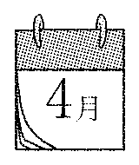
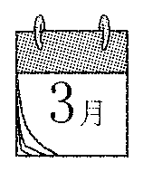
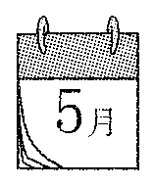
三、图文连线。

1. 2. 3.

April May March
四、根据汉语提示，从方框中选择短语，完成下列句子。
A. singing contest B. sports meet C. Chinese test
D. Easter party E. school trip

1. We will have a ______________ (运动会) next week.
2. The students in No. 1 School have a ______________ (学校旅行) in spring.
3. Do you have an ______________ (复活节聚会) every year?
4. They are ready for the ______________ (歌唱比赛).
5. Last Friday we had a ______________ (语文考试).
五、看图表，填空。

April | May
maths test  English test  Easter party | school trip  singing contest
1. A: When is the singing contest?
B: It’s in .
2. In April, we will have tests.
3. I like May. Because I can have a (学校旅行).
4. In ,we have more (更多的) activities (活动). 5. A: When is the ?
B: It’s in April.

答案：
一、1. A 2. B 3.A 4.C
二、3 4 2 1
三、1—March 2—April 3—May
四、1. B 2. E 3. D 4. A 5. C
五、1. May 2. maths and English 3. school trip
4. April 5. Easter party（答案不唯一）

听力材料：
一、听录音，选择你所听到的选项。
1. few 2. thing 3. meet 4. trip
二、听录音，给下面句子排列顺序。
1. We have a sports meet in autumn.
2. We have a few things in spring.
3. When is the party?
4. When is the school trip?

