Unit 3 单元测试
满分:100分 时间:60分钟 得分:
听力部分
一、听录音,给下列图片排序。(10分)
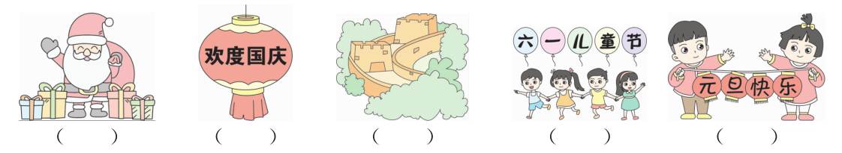
二、听录音,选单词。(10分)
( )1.A.November B.December C.September
( )2.A.January B.February C.October
( )3.A.June B.March C.April
( )4.A.June B.October C.April
( )5.A.summer B.spring C.autumn
三、听录音, 选择合适的答语。(10分)
( )1.A.It’s in May. B.It’s in June. C.It’s in July.
( )2.A.It’s in December. B.It’s in August. C.It’s in February.
( )3.A.Yes, it is. B.No, it isn’t. C.Yes, it does.
( )4.A.It’s in August. B.It’s in October. C.It’s in September.
( )5.A.I will eat mooncakes. B.I will eat turkey. C.I will eat zongzi.
笔试部分
四、选出下列单词中不同类的一项。(10分)
( )1.A.National Day B.teacher C.Thanksgiving Day
( )2.A.spring B.Christmas C.Easter
( )3.A.season B.spring C.summer
( )4.A.January B.Monday C.Sunday
( )5.A.mother B.father C.cake
五、选择正确的答案。(20分)
( )1.Tree Planting Day is March.
A.in B.on C.at
( )2.When the school trip this year?
A.is B.am C.are
( )3.Who go to the beach next week?
A.will B.do C.is
( )4.American Thanksgiving Day is in .
A.November B.December C.September
( )5.— Is the singing contest in May?
—
A.Yes, it will. B.Yes, it is. C.Yes, it does.
( )6.We’ll go to in September.
A.the Great Wall B.the great wall C.Great Wall
( )7.— When is New Year’s Day?
— It’s usually in .
A.March B.July C.January
( )8.In April, we a school trip.
A.have B.has C.will
( )9.— Will you come to the party?
—
A.Yes, it will. B.Yes, I will. C.Yes, I am.
( )10.Early planning is always .
A.well B.good C.best
六、从方框中选择合适的单词或短语,补全短文。(10分)
A.idea B.Teachers’ Day C.computer D.send E.e-card
Jenny: It’s September 10th. It’s 1 today. What are you going to do?
Tom: I’m going to 2 my teacher a card. What about you?
Jenny: I’m going to send an 3 to her.
Tom: Does she have a 4 ?
Jenny: Oh, no. She doesn’t have a computer.
Tom: You can send her a card, too.
Jenny: Good 5 .
七、给下列句子选择合适的答语。(10分)
( )1.When is China’s National Day?
( )2.Will she have a computer?
( )3.What’s the time?
( )4.What day is it today?
( )5.Is Children’s Day in July?
A.It’s Monday.
B.It’s in October.
C.It’s five o’clock.
D.No, it isn’t.
E.Yes, she will.
八、阅读短文,判断正(T)误(F)。(10分)
Hello, my name is Li Ming. I am making a birthday chart for my family.
My birthday is in June. My mother’s birthday is in June. My grandpa’s birthday is in June. My grandpa is in America. He lives with Uncle Bill and Aunt Mary. So I usually send him an e-card on his birthday.
There are two birthdays in November, my father’s and Cousin Alice’s. Alice likes dolls, so I often send her some beautiful dolls.
My grandma’s birthday is in April. It is very warm and nice in April. When her birthday comes, we often go hiking.
This is my chart, I love my family.
( )1.Does Li Ming’s grandpa live with Li Ming?
A.No, he doesn’t. B.Yes, he does. C.We don’t know.
( )2.How many birthdays are there in June?
A.2. B.4. C.3.
( )3.How many birthdays are there in April?
A.1. B.2. C.3.
( )4.What will Li Ming do for his grandpa’s birthday?
A.Send an e-mail. B.Send an e-card. C.Send a birthday cake.
( )5.When is Grandma’s birthday?
A.It’s in April. B.It’s in July. C.It’s in January.
九、写作。(10分)
用英语写一写复活节人们常做什么?吃什么?心情怎么样?
要求: 1.条理清楚,语法正确;
2.不少于五句话。

