Unit 2 My favourite season
Part B 第2课时（Let’s learn-ask and answer）
一、听录音，选择你所听到的选项。
（ ）1. A. picnic B. picture C. paper
（ ）2. A. pig B. pick C. page
（ ）3. A. woman B. snowman C. policeman
（ ）4. A. fishing B. doing C. swimming
二、听录音，排序。
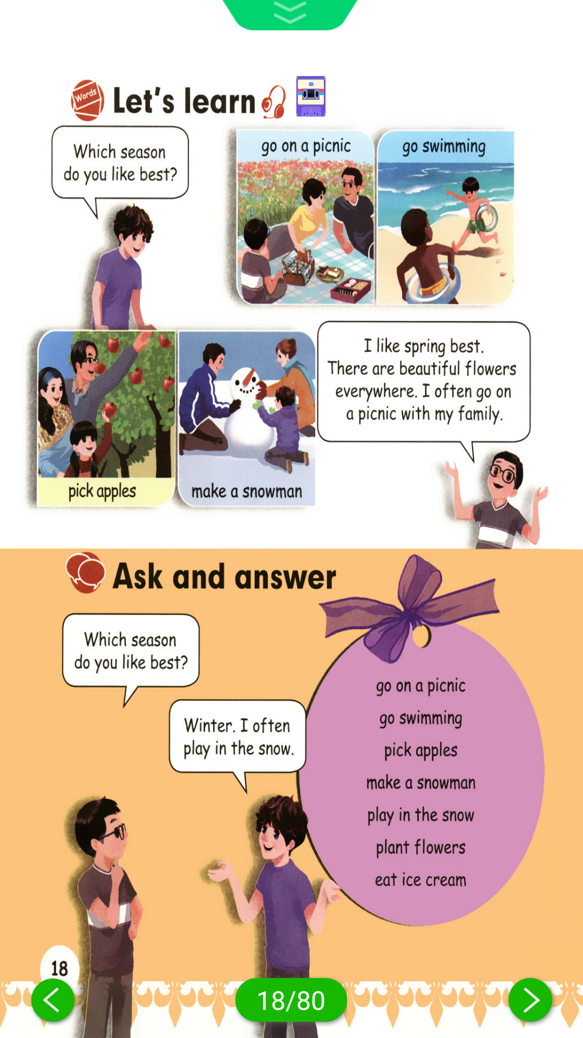
( ) ( ) ( ) ( )
三、英汉互译。
1. 去野餐 2. go swimming
3. 摘苹果 4. play in the snow
5. 堆雪人 6. pick oranges
四、选出不同类的一项。
( )1. A. picnic B. snowman C. pick
( )2. A. season B. colour C. make
( )3. A. which B. pick C. take
( )4. A. grow B. play C. picnic
( )5. A. summer B. Sunday C. autumn

五、看图完成对话。
1. —Which season do you like best?

—I like spring best. Because I can _______ with my friend.
2. —Which season do you like best?
—I like ________ best. Because I can ________.
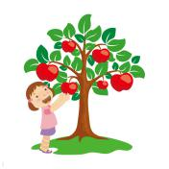
3. —Which season do you like best?
— I like ____________. Because ____________.
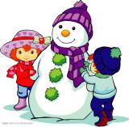
4. —Which season do you like best?
— ________________. ________________.

5. — ________________?
— ________________. ________________.
六、按要求完成下列各题。
1. I like summer. (对画线部分提问)

2. Why do you like winter? (用make a snowman回答)

答案：
一、1. A 2. B 3.B 4.C
二、3 2 1 4
三、1. go on a picnic 2.去游泳 3. pick apples
4. 在雪里玩 5. make a snowman 6. 摘橙子
四、1. C 2. C 3. A 4. C 5. B
五、1. fly a kite 2. summer; swim/go swimming 3. autumn; I can pick apples
4. I like winter best; Because I can make a snowman
5. Which season do you like best; I like spring best; Because I can go on a picnic
六、1. Which season do you like best?
2. Because I can make a snowman.

听力材料：
一、听录音，选择你所听到的选项。
1. picnic 2. pick 3. snowman 4. swimming
二、听录音，排序。
1. pick apples 2. go swimming 3. go on a picnic 4. make a snowman

