Unit 2 My favourite season
Part A第2课时（Let’s learn-Read and match）
一、听录音，判断下面句子是（√）否（×）正确。
( ) 1. Spring is green with flowers and songs.
( ) 2. Summer is hot and the days are long.
( ) 3. Autumn is golden and farmers are busy.
( ) 4. Winter is white and the year is gone.
二、听录音，给下面图片排列顺序。
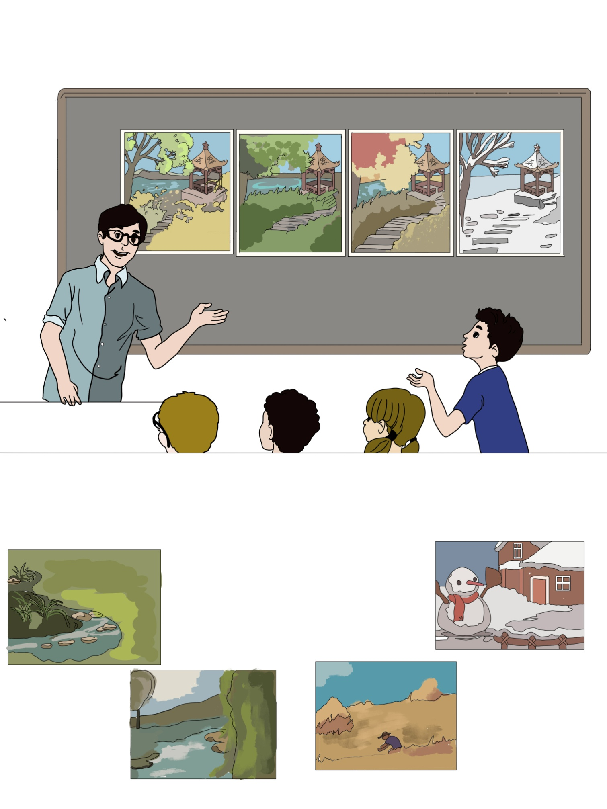

( ) ( ) ( ) ( )
三、完成下列单词。
1. p,s,r,g,n,i_______________ 2. u,s,e,m,r,m ___________
3. e,s,a,o,s,n ______________ 4. i,w,n,e,t,r ______________
5. u,n,a,t,m,u______________
四、选出不同类的单词。
( ) 1. A. winter B. summer C. autumn D. season
( ) 2. A. swim B. skate C. fly D. picnic
( ) 3. A. which B. best C. why D. what
( ) 4. A. weather B. windy C. rainy D. sunny
五、单项选择。
( ) 1. I don’t like ______. It’ s cold and snowy.
A. spring B. summer C. winter
( ) 2. I like summer best. I can ______ every day.
A. swimming B. swim C. shop
( ) 3. I like _____ best. It’s golden and the farmers are busy.
A. autumn B. winter C. spring
( ) 4. Winter is _____ and the year is gone.
A. green B. yellow C. white
六、阅读短文，判断句子与短文是（√）否（×）相符。
My name is Chen Jie. I’m from China. I’m a Chinese girl. I live in a big city. We have spring, summer, autumn and winter here. I like spring best. It’s windy and warm. We can fly kites in spring. It’s the best time to plant trees, too. I don’t like summer. It’s too hot. In winter it never snows in our city. So it’s not very cold.
( ) 1. There are four seasons in a year.
( ) 2. Summer is Chen Jie’s favourite season.
( ) 3. We can plant trees in winter.
( ) 4. Chen Jie doesn’t like summer because it’s hot.
( ) 5. It doesn’t snow in Chen Jie’s city.

答案：
一、1. × 2. √ 3. × 4. √
二、3 1 2 4
三、1. spring 2. summer 3. season 4. winter 5. autumn
四、1. D 2. D 3. B 4. A
五、1. C 2. B 3. A 4. C
六、1. √ 2. × 3. × 4. √ 5. √

听力材料：
一、听录音，判断下面句子是（√）否（×）正确。
1. Spring is blue with flowers and songs.
2. Summer is hot and the days are long.
3. Autumn is red and farmers are busy.
4. Winter is white and the year is gone.
- 听录音，给下面图片排列顺序。
1. summer 2. autumn 3. spring 4. winter

