Unit 1 My day
Part B 第2课时（Let’s learn-Do a survey）
一、听录音，选择你所听到的选项。
（ ）1. A. clean B. clever C. climb
（ ）2. A. work B. walk C. warm
（ ）3. A. talk B. take C. table
（ ）4. A. down B. dance C. dancing
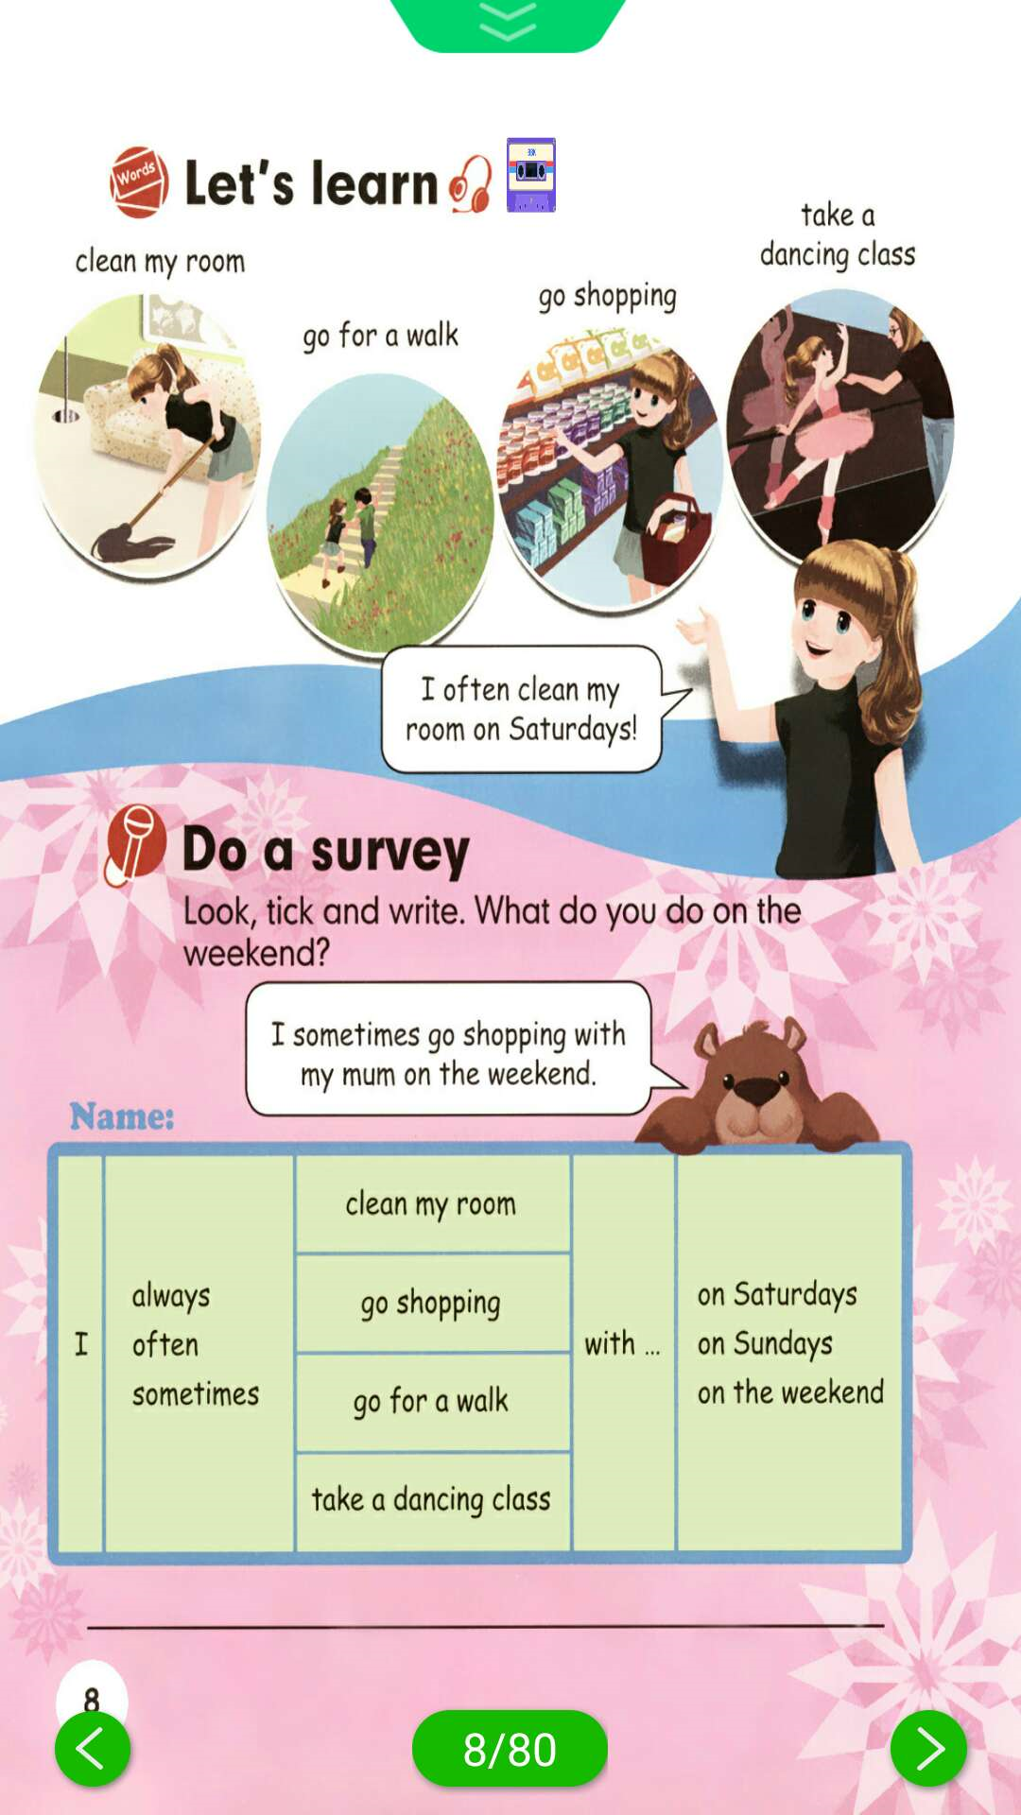
二、听录音，排序。

( ) ( ) ( ) ( )

三、看图填空。

1. I usually （上舞蹈课）on Saturdays.

2. I often （去买东西）on the weekend.

3. I often （散步）in the morning.

4. I often （打扫我的房间）on Sunday.
四、选择合适的动词填空。
go have do play

1. homework 2. dinner 3. classes
4. shopping 5. breakfast 6. sports
五、英汉连线。
1. go shopping with my mum A. 擦窗户
2. take a dancing class B. 去散步
3. clean the window C. 上舞蹈课
4. go for a walk D. 和我的妈妈去购物
六、阅读短文，判断正（T）误（F）。
Hello, I am Tim. It’s Sunday today. Today I have many things to do. I get up at
6 o’clock, and then I do morning exercises. After that I eat breakfast and do my homework. At 10:30, I play sports with my classmates. I eat lunch at 12:00. In the afternoon, I go to the park with my friends and I have a picnic there. In the evening, I watch TV. And I go to bed at 9:00. What a nice day!
( ) 1. It’s Saturday today.
( ) 2. Tim gets up at 6 o’clock every day.
( ) 3. Tim does his homework before 10:30.
( ) 4. Tim goes to the park with his parents and has a picnic there.
( ) 5. Tim goes to bed at 9 o’clock in the evening.

答案：
一、1. A 2. B 3.B 4.C
二、3 2 4 1
三、1. take a dancing class 2. go shopping 3. go for a walk 4. clean my room
四、1. do 2. have 3. have 4. go 5. have 6. play
五、1—D 2—C 3—A 4—B
六、1. F 2. F 3. T 4. F 5. T

听力材料：
一、听录音，选择你所听到的选项。
1. clean 2. walk 3. take 4. dancing
二、听录音，排序。
1. take a dancing class
2. go for a walk
3. clean my room
4. go shopping

