Unit 1 My day
满分:100分 时间:60分钟 得分:
听力部分
一、听录音,连线。(10分)
1.  A.7:30 a.m.
2. B.10:00 a.m.
3. C.5:30 p.m.
4.  D.3:00 p.m.
5. E.6:50 a.m.
二、听录音,给下列句子选择合适的答语。(10分)
( )1.When does Mike get up?
A.At 6:30 a.m. B.At 6:50 a.m. C.At 7:10 a.m.
( )2.What day is the next day?
A.Thursday. B.Friday. C.Saturday.
( )3.When does Miss White go home?
A.At 6:30 a.m. B.At 5:40 p.m. C.At 7:20 p.m.
( )4.What does Zip do on the weekend?
A.He does his homework. B.He plays football. C.He watches TV.
( )5.Is Sarah going to visit her grandparents this weekend?
A.Yes, she is. B.No, she isn’t. C.We don’t know.
三、听录音,判断正(T)误(F)。(10分)
( )1.I usually get up at six from Monday to Friday.
( )2.I eat breakfast at home.
( )3.Then I do morning exercises at home.
( )4.On the weekend, I often climb mountains.
( )5.Sometimes I visit my grandparents and eat dinner with them.
笔试部分
四、选出下列单词中不同类的一项。(10分)
( )1.A.school B.lunch C.breakfast
( )2.A.policeman B.teacher C.English
( )3.A.visit B.play C.weekend
( )4.A.Tuesday B.Friday C.football
( )5.A.shopping B.work C.hiking
五、给下列图片选择对应的短语。(10分)
A.play football B.watch TV C.eat dinner
D.climb mountains E.play the piano
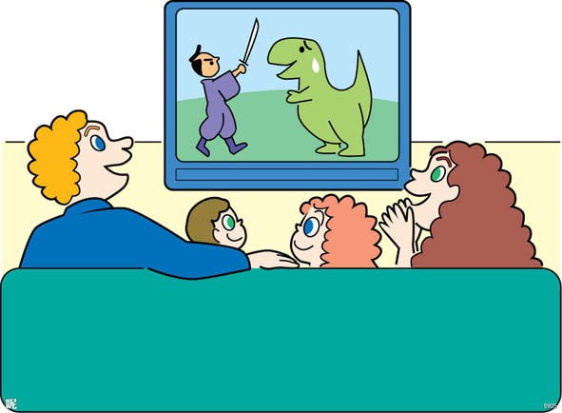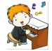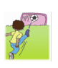
1. 2. 3. 4. 5.

六、选择正确的答案。(20分)
( )1.— do you usually go to school?
— At 7:00.
A.What B.Where C.When
( )2.I usually get up 6:30.
A.on B.at C.in
( )3. Look! Many boys like playing after class.
A.a basketball B.the basketball C.basketball
( )4.I go fishing on Sundays.
A.some times B.sometimes C.some time
( )5.Students like playing .
A.sports B.the sport C.a sport
( )6.I often go swimming on the weekend. What you?
A.are B.about C.do
( )7.Let’s go together next Sunday.
A.shoping B.shop C.shopping
( )8.— Do you like going shopping on Sundays?
—
A.Yes, I am. B.Yes, I do. C.Yes, I don’t.
( )9.— What do you have on Mondays?
—
A.I have a book. B.I have Chinese. C.I read books.
( )10.— What you ?
— I can clean the room.
A.do; do B.are; do C.can; do
七、给下列句子选择相符的图片。(10分)
A.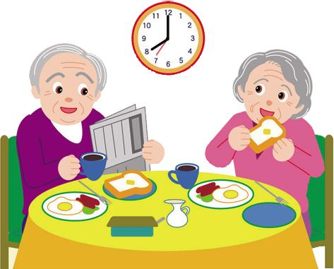 B.  C.  D.  E.
( )1.I do my homework every evening.
( )2.She visits her grandmother on the weekend.
( )3.I often play football on the weekend.
( )4.They usually eat breakfast at 8:00 a.m.
( )5.We often play sports after class.
八、阅读短文,判断正(T)误(F)。(10分)
I’m Wang Gang. I’m an English teacher. I go to work from Monday to Friday. I usually get up at 6:00 in the morning. Then I do morning exercises. I eat breakfast at 7:00. After breakfast I go to work. I usually have two classes in the morning and one in the afternoon. I usually play sports at 4:00 p.m. I go home at 5:30 p.m. After dinner I usually watch TV and read books. Then I go to bed at 10:00 p.m. What about you?
( )1.Wang Gang is a policeman.
( )2.He eats breakfast at 7:00.
( )3.He has three classes in the morning.
( )4.He usually plays sports at 3:00 in the afternoon.
( )5.He goes to bed at 10:00 in the evening.
九、写作。(10分)
以This is my day为题,写一写你一天的安排。
要求:1.条理清楚,语法正确;
2.书写规范,认真;
3.不少于五句话。

