期末测试
满分:100分 时间:60分钟 得分:
听力部分
一、听录音,选单词。(10分)
( )1.A.leaves B.left C.love
( )2.A.week B.weekend C.watching
( )3.A.shopping B.swimming C.Saturday
( )4.A.tigers B.come C.there
( )5.A.12th B.2nd C.20th
二、听录音,给下列图片排序。(10分)
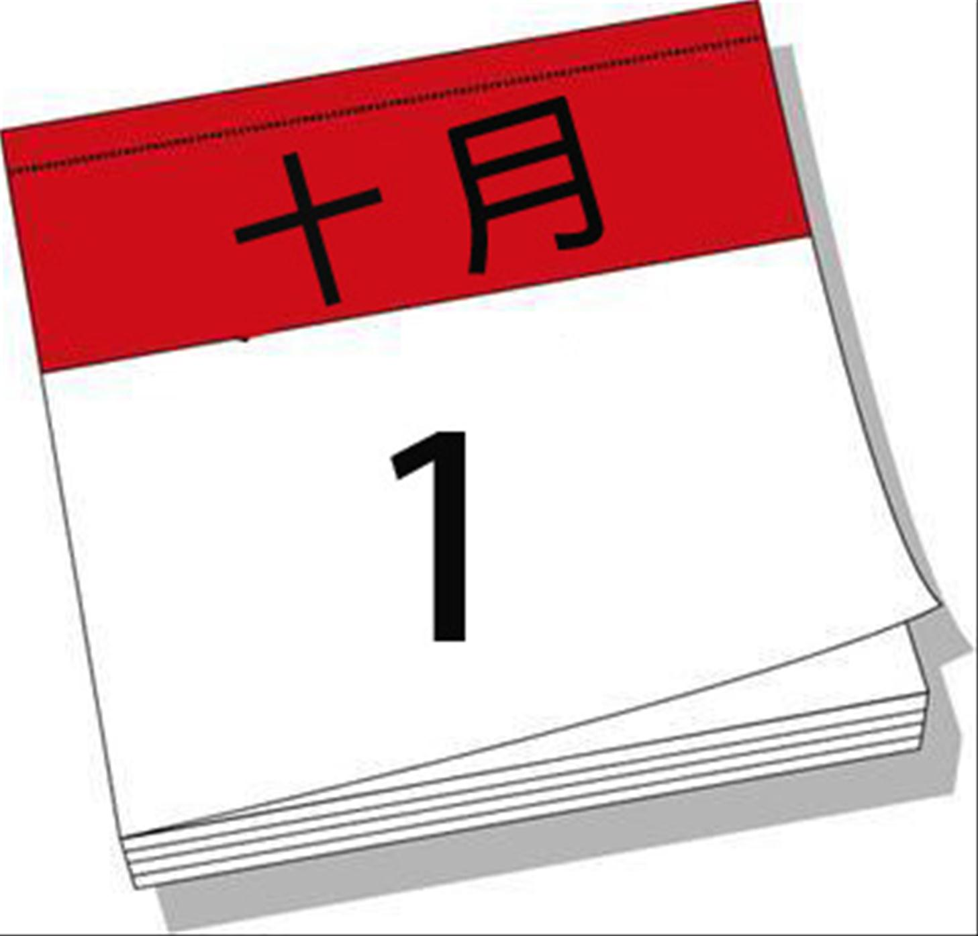
( ) ( ) ( ) ( ) ( )
三、听录音,判断正(T)误(F)。(10分)
( )1. Amy is going to Australia by plane.
( )2.It is spring in Australia.
( )3.Amy can make a snowman in Australia this weekend.
( )4.Amy’s grandpa’s birthday is on Thursday.
( )5.Amy is making a birthday cake now.
笔试部分
四、选出不同类的一项。(10分)
( )1.A.play sports B.play football C.play basketball
( )2.A.why B.weekend C.when
( )3.A.Jan. B.Monday C.Aug.
( )4.A.ninth B.fifth C.twenty
( )5.A.often B.sometimes C.season
五、根据图片或汉语提示,补全句子。(10分)
1.It is June 1st. Today is (儿童节) .
2.Mike is . 
3.Look! There is a bird. It’s . 
4.He at seven every morning. 
5.— What are they doing? — They are . 
六、选择正确的答案。(20分)
( )1.— When do you finish class in the morning?
—
A.At 11 o’clock. B.English. C.Summer.
( )2.My birthday is May.
A.on B.at C.in
( )3.— When is April Fool’s Day? —
A.It’s Tuesday. B.It’s cool. C.It’s on April 1st.
( )4.What do you do the weekend?
A.on B.in C.of
( )5.August is the month of the year.
A.seven B.ninth C.eighth
( )6.— What is John doing? — He .
A.running B.swims in the river C.is walking
( )7.— do you like summer?
— I can eat ice cream.
A.Why; Because B.Why; And C.Which; Because
( )8.June 1st is .
A.Children’s Day B.New Year’s Day C.Army Day
( )9.— — We will sing a song.
A.What do they do? B.What are you doing?C.What will you do?
( )10.Shh. The baby is sleeping.
A.Please keep quiet. B.Take turns. C.Keep the desk clean.
七、选句子,完成对话。(10分)
Jack: Hello. This is Jack. 1
Child: Sure.
Jack: When’s your birthday?
Child: 2
Jack: 3
Child: Her birthday is on June 20th.
Jack: When is your father’s birthday?
Child: 4
Jack: 5
Child: January 30th.
Jack: Thank you.
Child: You’re welcome. Bye.
A.It’s on May 2nd.
B.When is your brother’s birthday?
C.His birthday is on December 3rd.
D.Can I ask you some questions?
E.When is your mother’s birthday?
八、给下列句子选择合适的答语。(10分)
( )1.What do you do on the weekend? A.No, I’m going hiking.
( )2.When is Army Day? B.I’m reading a book.
( )3.Which season do you like best? C.August 1st.
( )4.Are you climbing the mountain? D. Winter. I can play in the snow.
( )5.What are you doing? E.I often do my homework.
九、阅读短文,判断正(T)误(F)。(10分)
It’s a Sunday morning. It’s sunny. There are many people in the park. Some students are playing games over there. Two boys are playing football. A girl is flying a kite. Two children are running on the grass.
There is a house near the lake. Beside the house two men are working. A woman is watering the flowers. The flowers are very nice.
( )1.There are many people in the park on Sunday.
( )2.The students are playing games in the zoo.
( )3.The boys are playing football.
( )4.Two children are flying kites.
( )5.A woman is watering the flowers near the house.

