Recycle 1 第2课时
一、听录音，选择你所听到的选项。
（ ）1. A. film B. favourite C. five
（ ）2. A. west B. weather C. water
（ ）3. A. family B. festival C. famous
（ ）4. A. summer B. some C. sunny
二、听录音，给下面句子排列顺序。
（ ）In winter I get up at night.
（ ）In summer I go to bed by day.
（ ）What is the weather like in spring?
（ ）What is the weather like in summer?
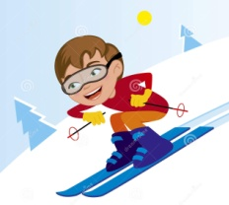
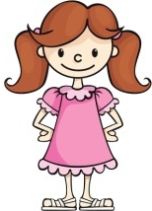
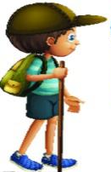
三、读句子，选出对应的图片。
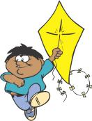

A B C D E
( )1. I like spring. Because I can fly kites in the wind.
( )2. I like winter. Because 1 like to ski on the snow.
( )3. I like summer. Because I can wear my T-shirt and my shorts.
( )4. I like autumn and it's windy. Yellow leaves are falling down.
( )5. I like summer, because I can wear my favourite dress.
四、单项选择。
( )1. Teachers’ Day is_________ September.
A. at B. in C. on
( )2. My birthday is in May. ________ yours?
A. How B. What C. What about
( )3. _________ do you go back home after school?
A. Who B. Whose C. When
( )4. I________ summer, but Mike________ autumn.
A. like; like B. likes; likes C. like; likes
五、选择合适的句子，补全对话(有两项多余)。
Amy: 1._________
A. Why do you like spring?
B. What do you do?
C. What do you do in winter?
D. What about you?
E. Why do you like winter?
F. What's the weather like today, Helen?
G. Which season do you like best?
Helen: It's windy and warm.
Amy: 2. _________
Helen: Spring.
Amy: 3. _________
Helen: Because I can plant trees.4. _________
Amy: I like winter best.
Helen: 5. _________
Amy: Because I can play in the snow.

答案：
一、1. B 2. B 3.C 4.A
二、3 2 4 1
三、1. D 2. A 3. B 4. C 5. E
四、1. B 2. C 3. C 4. C
五、1. F 2. G 3. A 4. D 5. E

听力材料：
一、听录音，选择你所听到的选项。
1. favourite 2. weather 3. famous 4. summer
二、听录音，给下面句子排列顺序。
1. What is the weather like in summer?
2. In summer I go to bed by day.
3. In winter I get up at night.
4. What is the weather like in spring?

